Kubernetes Security Primitives:
we look at the security parameters in Kubernetes. Kubernetes being the go-to platform for hosting production grid applications. Security is of prime concern. we look at the various security primitives in Kubernetes at a high level, before diving deeper into those in the upcoming lectures, let's begin with the hosts that formed the cluster itself.
All access to these hosts must be secured root access disabled, password-based authentication disabled, and only SSH key based authentication to be made available and of course, any other measures you need to take to secure your physical or virtual infrastructure that hosts Kubernetes. if that is compromised, everything is compromised.
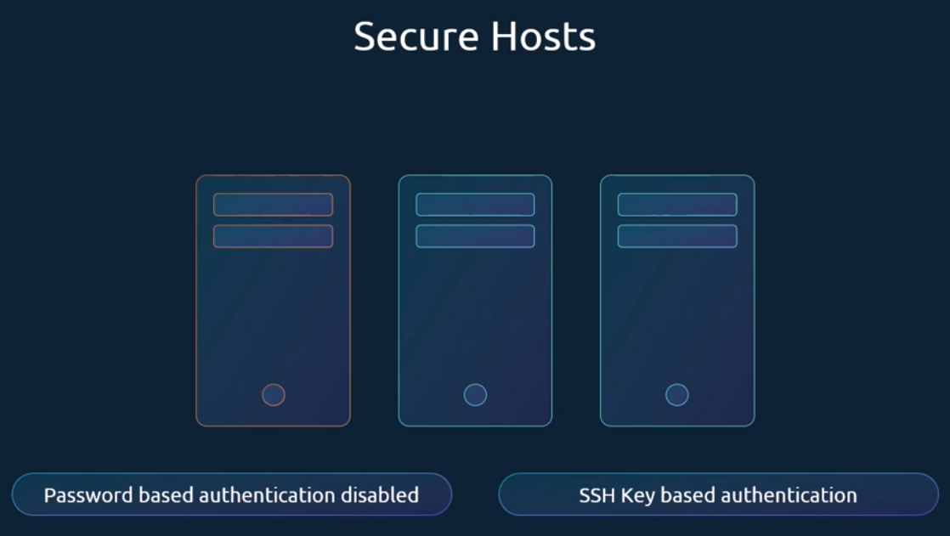
Our focus in this lecture is more on Kubernetes related security. What are the risks and what measures do you need to take to secure the cluster? As we have seen already, the kube API server is at the center of all operations within Kubernetes. We interact with it through the kube control utility or by accessing the API directly. And through that you can perform almost any operation on the cluster. So that's the first line of defense. Controlling access to the API server itself.
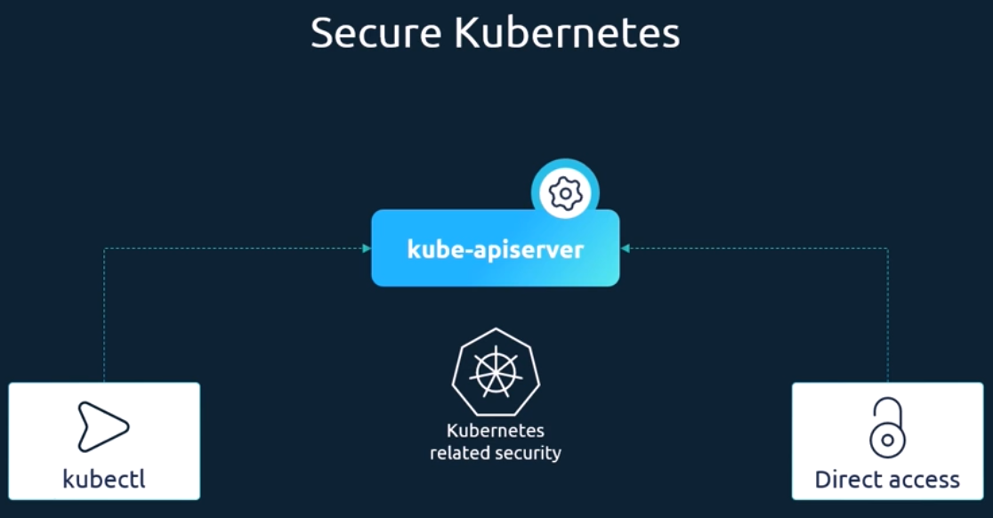
We need to make two types of decisions. Who can access the cluster and what can they do. Who can access the API server is defined by the authentication mechanisms. There are different ways that you can authenticate to the API server certificates, or even an integration with external authentication providers like Ldap. Finally, for machines we create service accounts.
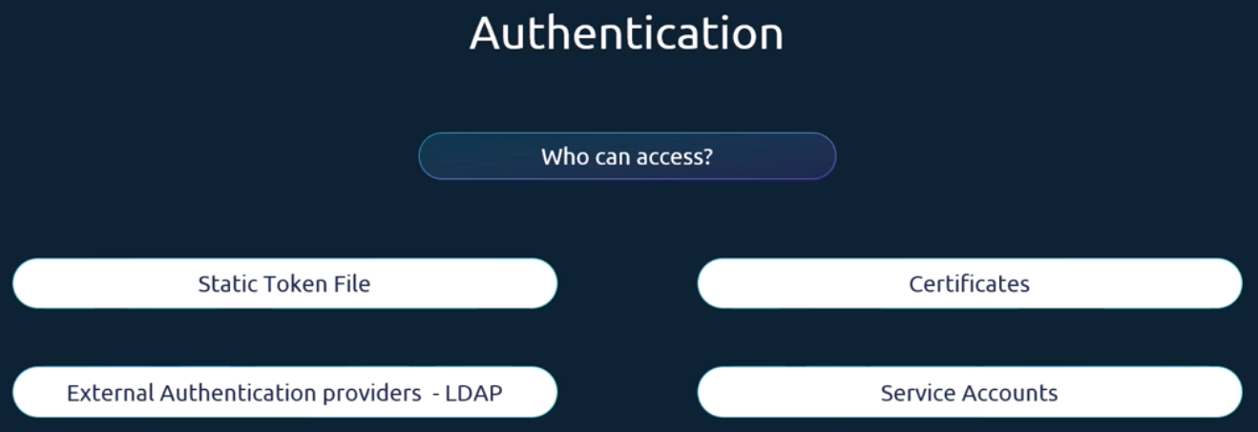
once they gain access to the cluster. What can they do is defined by authorization mechanisms. Authorization is implemented using role-based access controls, where users are associated to groups with specific permissions. In addition, there are other authorization modules like the attribute-based access Control node, Authorizers, webhooks, etc.
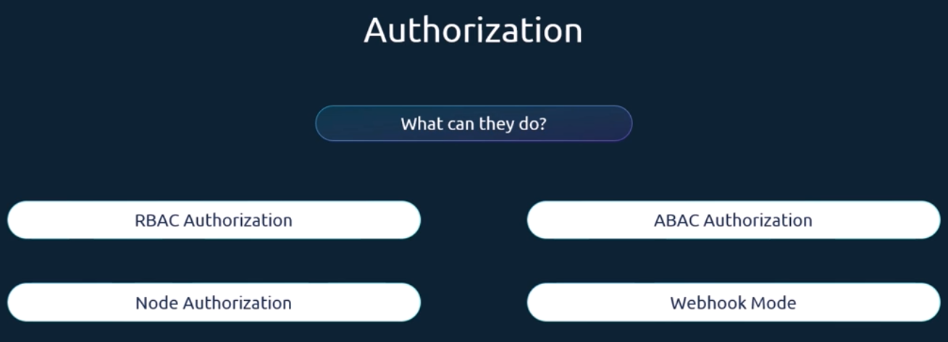
All communication with the cluster between the various components such as the etcd cluster, the kube controller, manager, scheduler, API server, as well as those running on the worker nodes such as the Kubelet and kube proxy, is secured using TLS encryption.
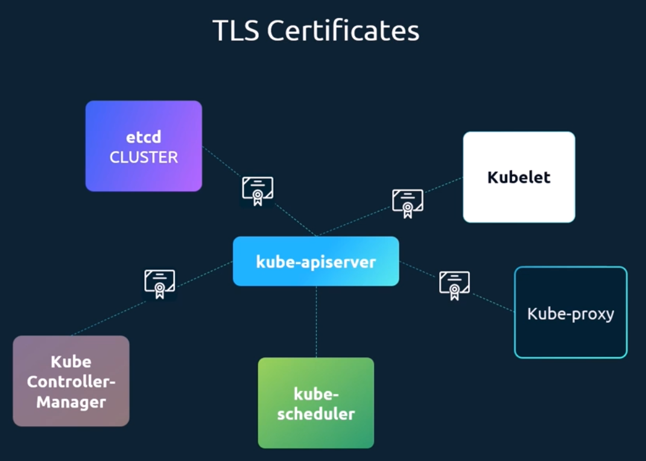
What about communication between applications within the cluster? By default, all pods can access all other pods within the cluster. Now you can restrict access between them using network policies.
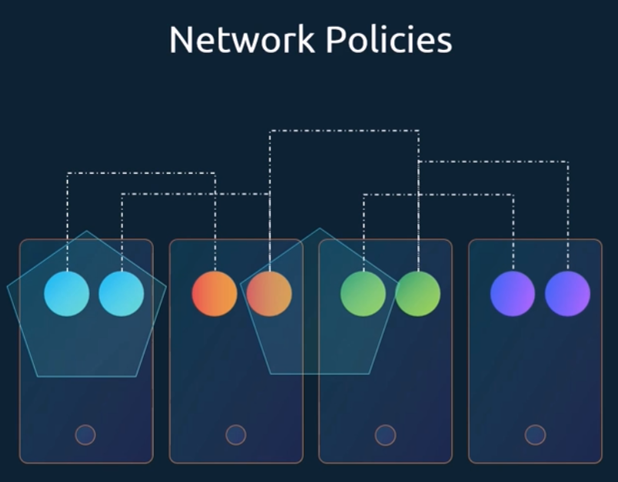

Authentication:
As we have seen already, the Kubernetes cluster consists of multiple nodes physical or virtual, and various components that work together. You have users, like administrators that access the cluster to perform administrative tasks, the developers that access the cluster to test or deploy applications. We have end users who access the applications deployed on the cluster, and we have third party applications accessing the cluster for integration purposes.
Throughout this section, we will discuss how to secure our cluster by securing the communication between internal components and securing management access to the cluster through authentication and authorization mechanisms. In this lecture, our focus is on securing access to the Kubernetes cluster with authentication mechanisms.
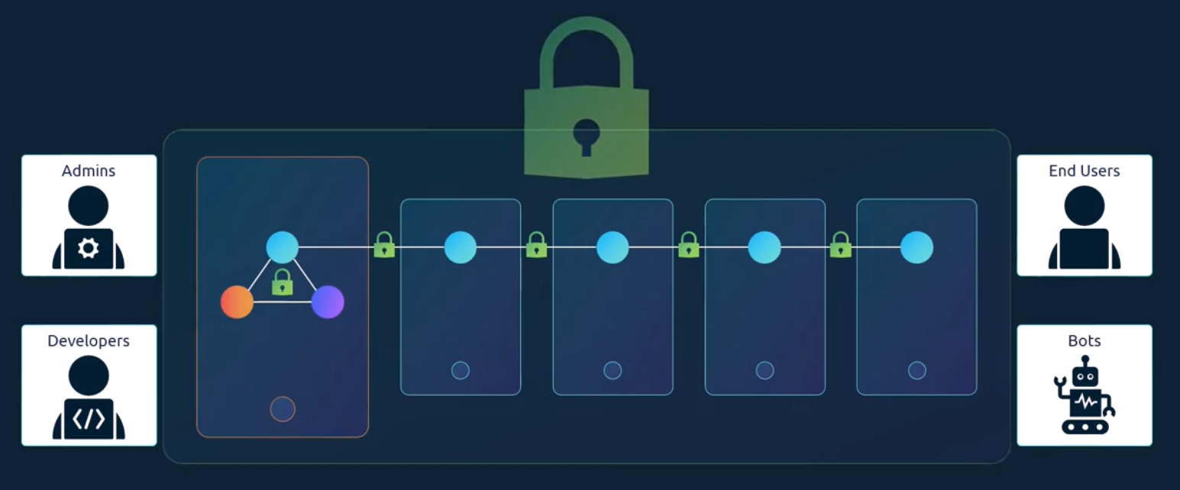
We talked about the different users that may be accessing the cluster. Security of end users who access the applications deployed on the cluster is managed by the applications themselves internally, we will take them out of our discussion.
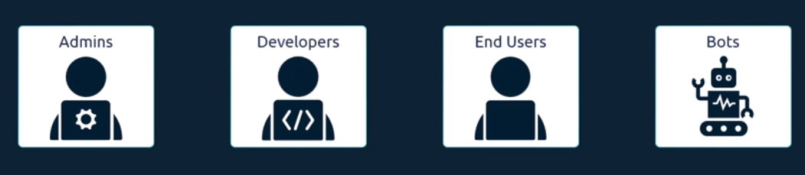
Our focus is on users access to the Kubernetes cluster for administrative purposes. we are left with two types of user’s humans, such as the administrators and developers, and robots, such as other processes or services or applications that require access to the cluster.
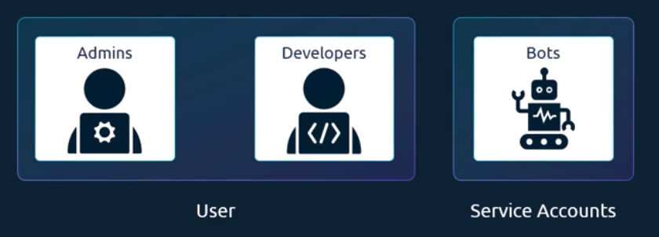
Kubernetes does not manage user accounts natively. It relies on an external source, like a file with user details or certificates, or a third-party identity service like Ldap to manage these users and so you cannot create users in a Kubernetes cluster or view the list of users like this.
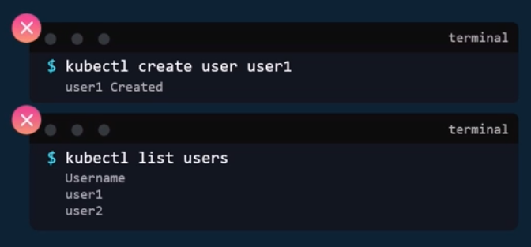
However, in case of service accounts, Kubernetes can manage them. You can create and manage service accounts using the Kubernetes API. We have a section on service accounts exclusively where we discuss and practice more about service accounts.
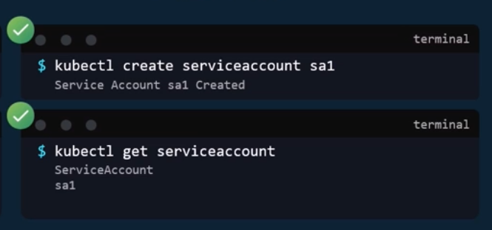
For this lecture we will focus on users in Kubernetes, all user access is managed by the API server. Whether you're accessing the cluster through kube control tool or the API directly. All of these requests go through the kube API server. The kube API server authenticates the requests before processing it.
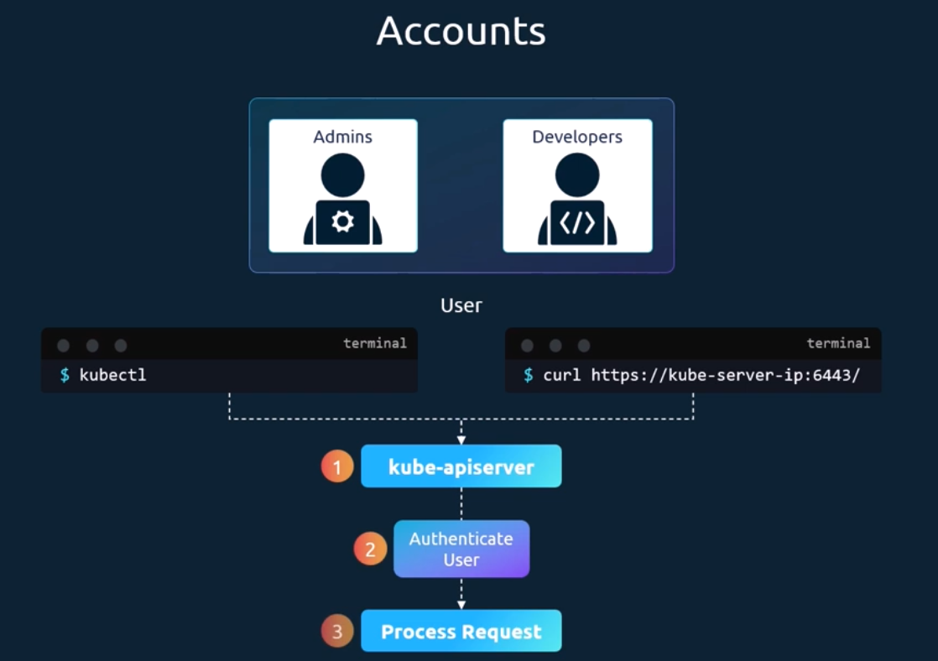
So how does the kube API server authenticate? There are different authentication mechanisms that can be configured. You can have usernames and tokens in a static token file. Or you can authenticate using certificates. And another option is to connect to third party authentication protocols like Ldap, Kerberos, etc.
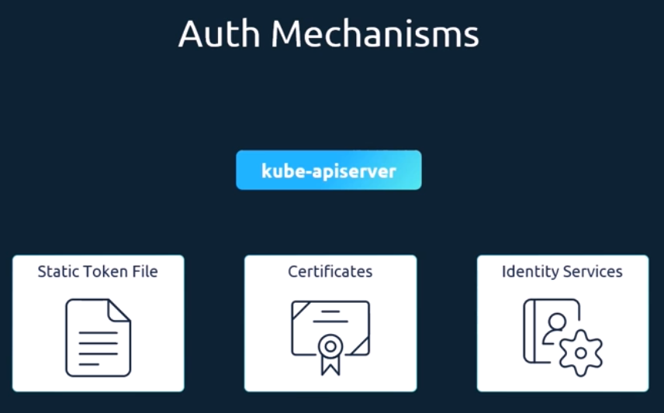
Let's start with static password and token files as it is the easiest to understand. In the CSV file with the user details that we saw, we can optionally have a fourth column with the group details to assign users to specific groups. Similarly, instead of a static password file, you can have a static token file. Here, instead of password, is specify a token. Pass the token file as an option token auth file to the kube API server. While authenticating, specify the token as an authorization bearer token peer requests like this.
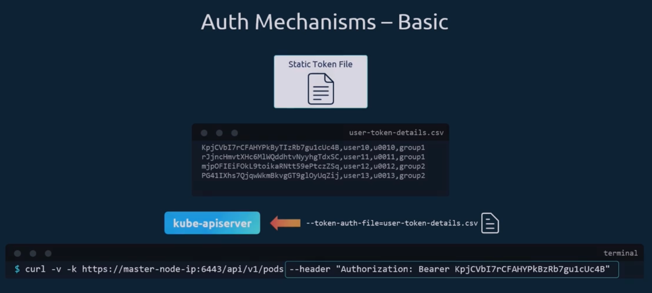
Remember that this authentication mechanism that stores usernames, passwords, and tokens in clear text in a static file is not a recommended approach as it is insecure. But I thought this was the easiest way to understand the basics of authentication in Kubernetes.

TLS Basics:
We will look at the absolute basics of what TLS certificates are, why you need them, and how you can configure certificates to secure SSH or web servers. A certificate is used to guarantee trust between two parties during a transaction. For example, when a user tries to access a web server, TLS certificates ensure that the communication between the user and the server is encrypted and the server is who it says it is.
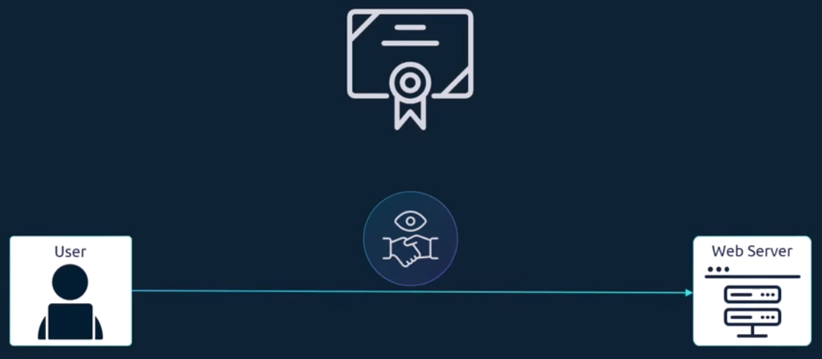
Let's take a look at a scenario without secure connectivity. If a user were to access his online banking application, the credentials he types in would be sent in a plain text format. The hacker sniffing network traffic could easily retrieve the credentials and use it to hack into the user's bank account.
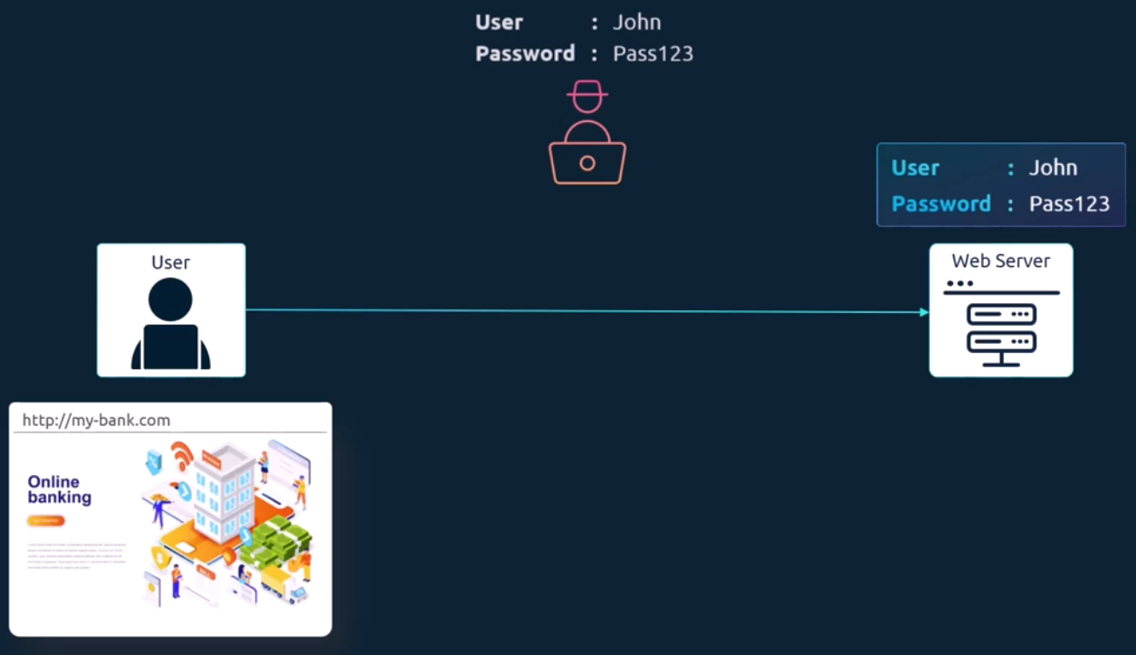
Well, that's obviously not safe, so you must encrypt the data being transferred using encryption keys. The data is encrypted using a key, which is basically a set of random numbers and alphabets.
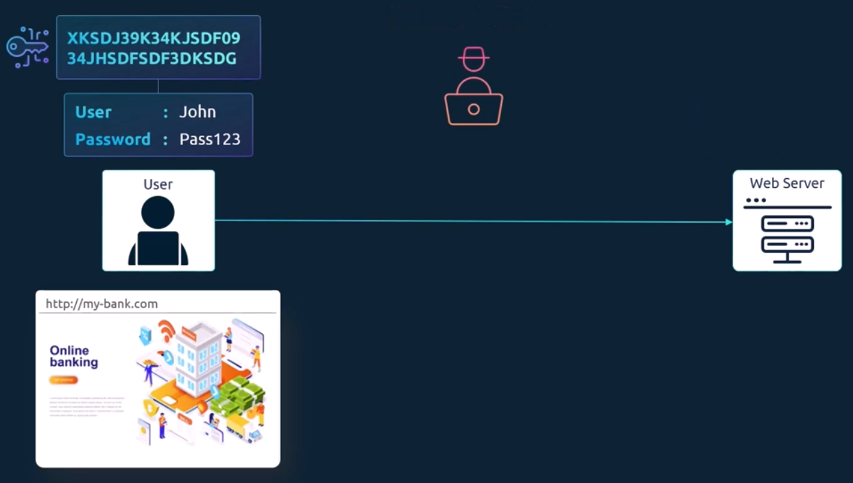
You add the random number to your data, and you encrypt it into a format that cannot be recognized. The data is then sent to the server. The hacker sniffing the network gets the data but can't do anything with it.
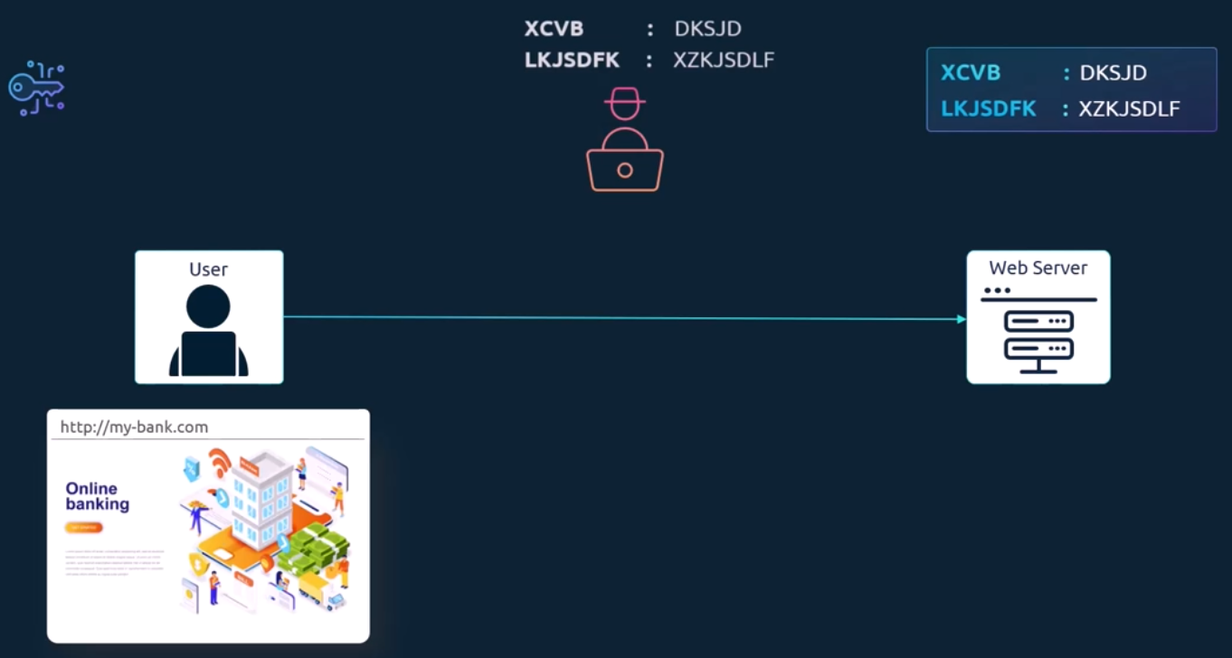
However, the same is the case with the server receiving the data. It cannot decrypt the data without the key. a copy of the key must also be sent to the server so that the server can decrypt and read the message. Since the key is also sent over the same network, the attacker can sniff that as well and decrypt the data with it. This is known as symmetric encryption.
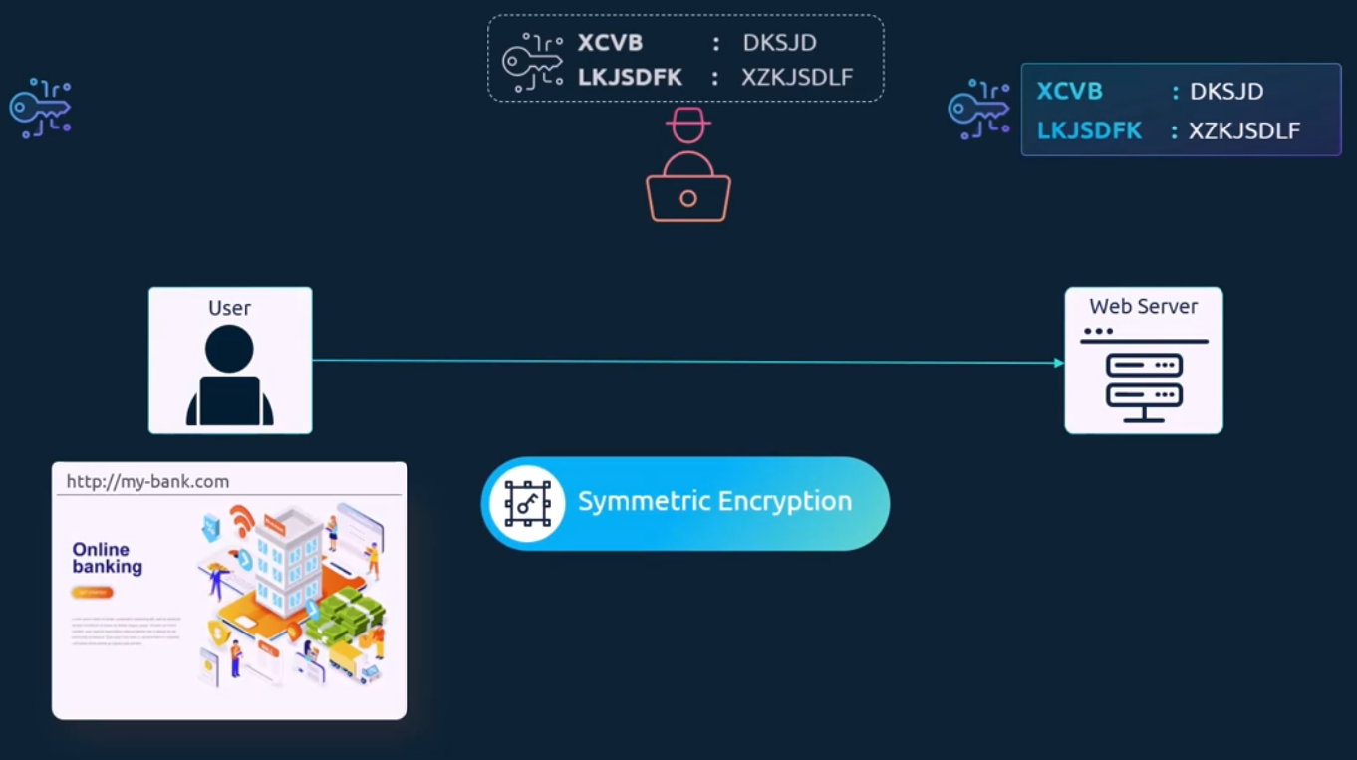
It is a secure way of encryption, but since it uses the same key to encrypt and decrypt the data, and since the key has to be exchanged between the sender and the receiver. There is a risk of a hacker gaining access to the key and decrypting the data.
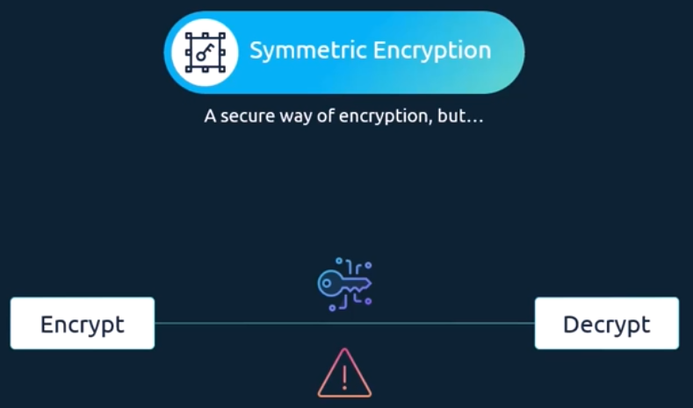
And that's where asymmetric encryption comes in. Instead of using a single key to encrypt and decrypt data, asymmetric encryption uses a pair of keys, a private key, and a public key. Well, their private and public keys. But for the sake of this example, we will call it a private key and a public lock. We will get back to that at the end, but for now, think of it as a key and a lock pair. A key which is only with me, it's private. A lock that anyone can access, it's public. The trick here is if you encrypt or lock the data with your lock, you can only open it with the associated key. your key must always be secure with you and not be shared with anyone else. It's private, but the lock is public and may be shared with others, but they can only lock something with it no matter what is locked using the public lock. It can only be unlocked by your private key.
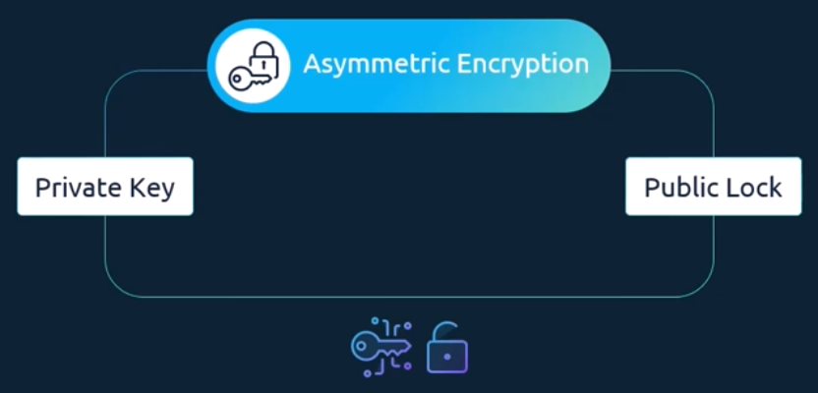
Before we go back to our web server example, let's look at an even simpler use case of securing SSH access to servers using key pairs. You have a server in your environment that you need access to. You don't want to use passwords as they are too risky, so you decide to use key pairs. You generate a public and private key pair. You can do this by running the ssh keygen command. It creates two files id underscore RSA is the private key and id underscore RSA dot pub is the public key. Well not a public key a public lock. You then secure your server by locking down all access to it except through a door that is locked using your public lock. It's usually done by adding an entry with your public key into the server's SSH authorized underscore keys file. you see, the lock is public and anyone can attempt to break through. But as long as no one gets their hands on your private key, which is safe with you on your laptop, no one can gain access to the server. When you try to SSH, you specify the location of your private key in your SSH command. What if you have other servers in your environment? How do you secure more than one server with your key pair? Well, you can create copies of your public log and place them on as many servers as you want. You can use the same private key to SSH into all of your servers securely.
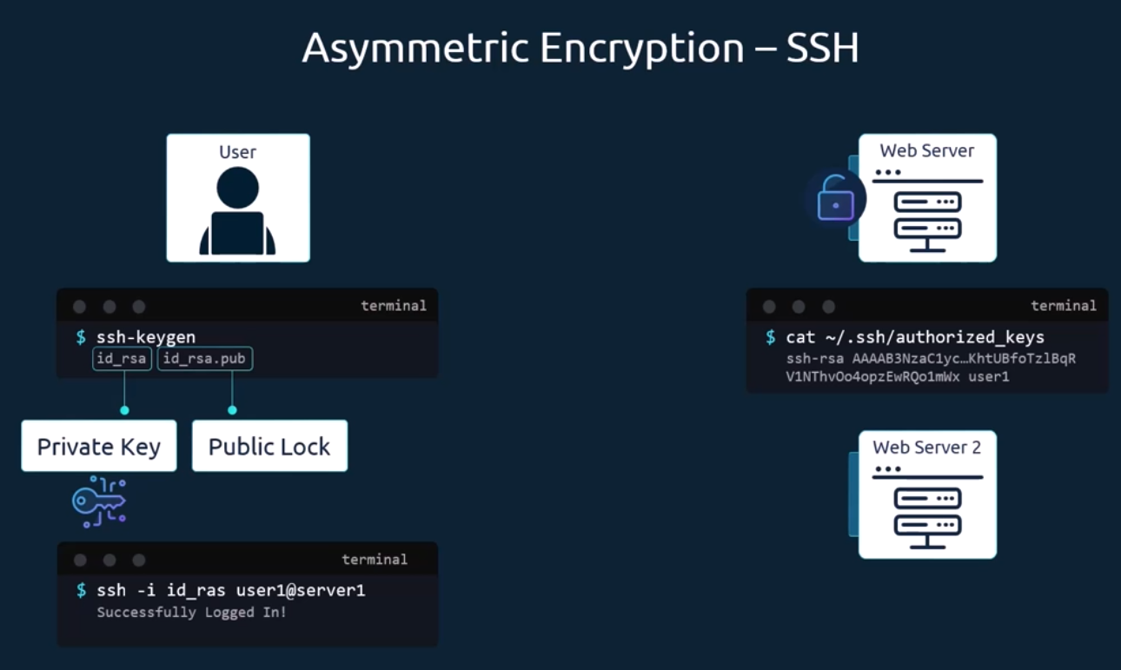
What if other users need access to your servers? Well, they can do the same thing. They can generate their own public and private key pairs. As the only person who has access to those servers, you can create an additional door for them and lock it with their public locks. Copy their public logs to all the servers, and now other users can access the servers using their private keys.
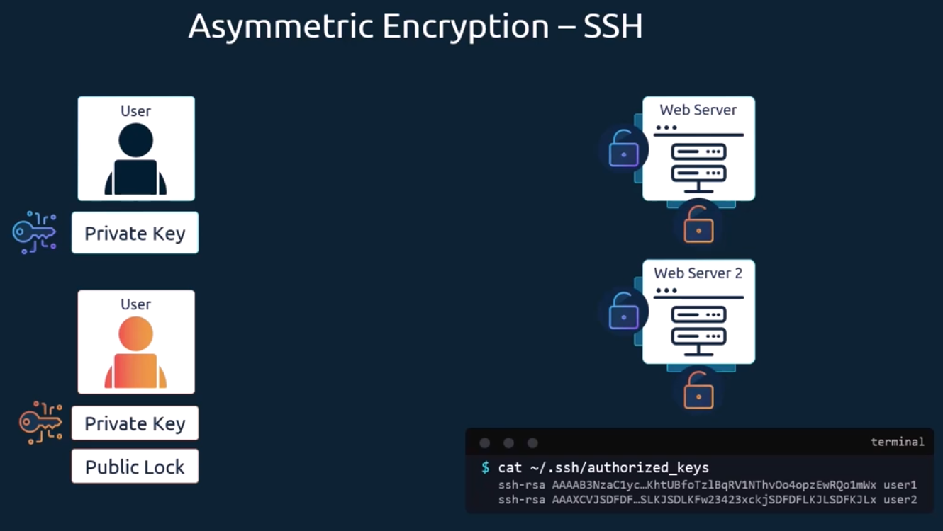
Let's go back to our web server example. You see, the problem we had earlier with symmetric encryption was that the key used to encrypt data had to be sent to the server over the network, along with the encrypted data and there is a risk of the hacker getting the key to decrypt the data.
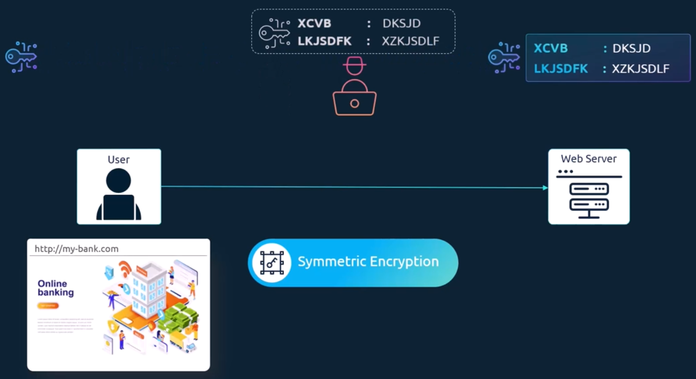
What if we could somehow get the key to the server safely?
Once the key is safely made available to the server, the server and client can safely continue communication with each other using symmetric encryption to securely transfer the symmetric key from the client to the server. We use asymmetric encryption; we generate a public and private key pair on the server. We're going to refer to the public lock as public key going forward. Now that you have got the idea, the ssh keygen command was used earlier to create a pair of keys for ssh purposes, the format is a bit different.
We use the OpenSSL command to generate a private and public key pair.
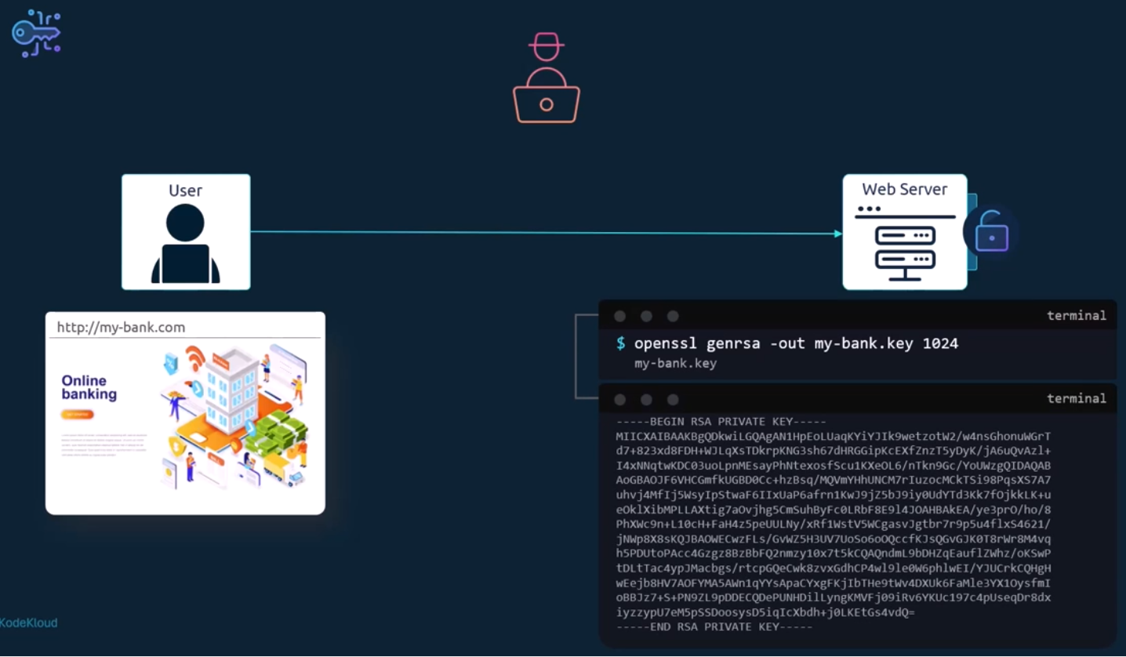
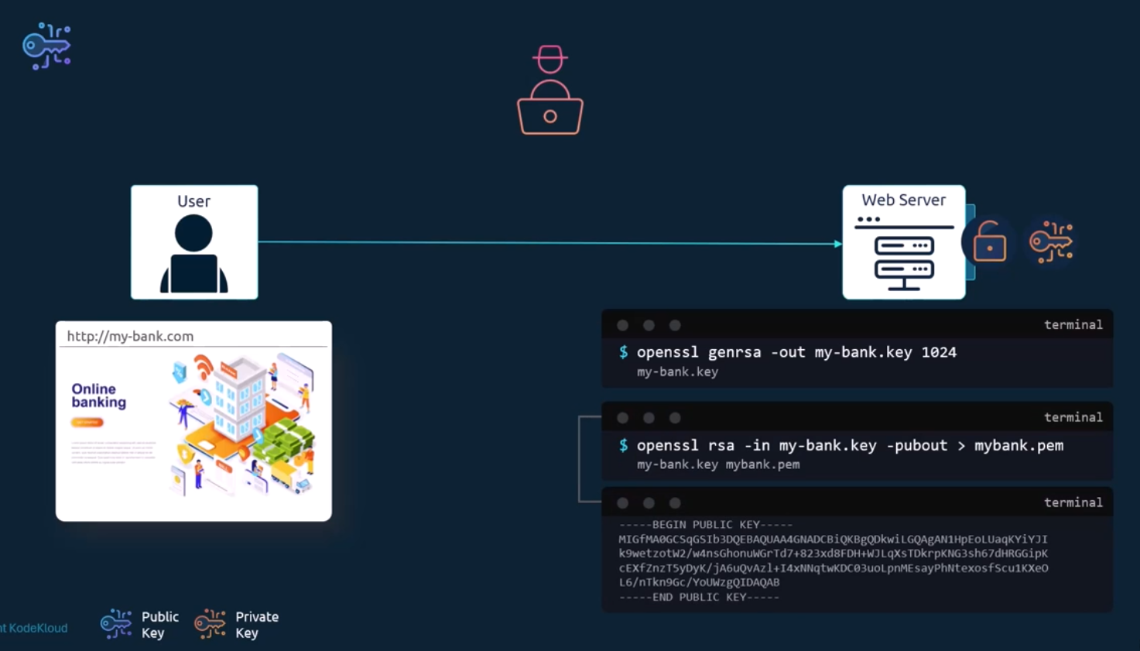
When the user first accesses the web server using https, he gets the public key from the server. Since the hacker is sniffing all traffic. Let us assume he two gets a copy of the public key. We'll see what he can do with it. In fact, the user's browser then encrypts the symmetric key using the public key provided by the server. The symmetric key is now secure. The user then sends this to the server. The hacker also gets a copy. The server uses the private key to decrypt the message and retrieve the symmetric key from it. However, the hacker does not have the private key to decrypt and retrieve the symmetric key from the message it received. The hacker only has the public key with which he can only lock or encrypt a message, and not decrypt the message. The symmetric key is now safely available only to the user and the server. They can now use the symmetric key to encrypt data and send to each other. The receiver can use the same symmetric key to decrypt data and retrieve information. The hacker is left with the encrypted messages and public keys with which he can't decrypt any data. With asymmetric encryption, we have successfully transferred the symmetric keys from the user to the server and with symmetric encryption, we have secured all future communication between them.
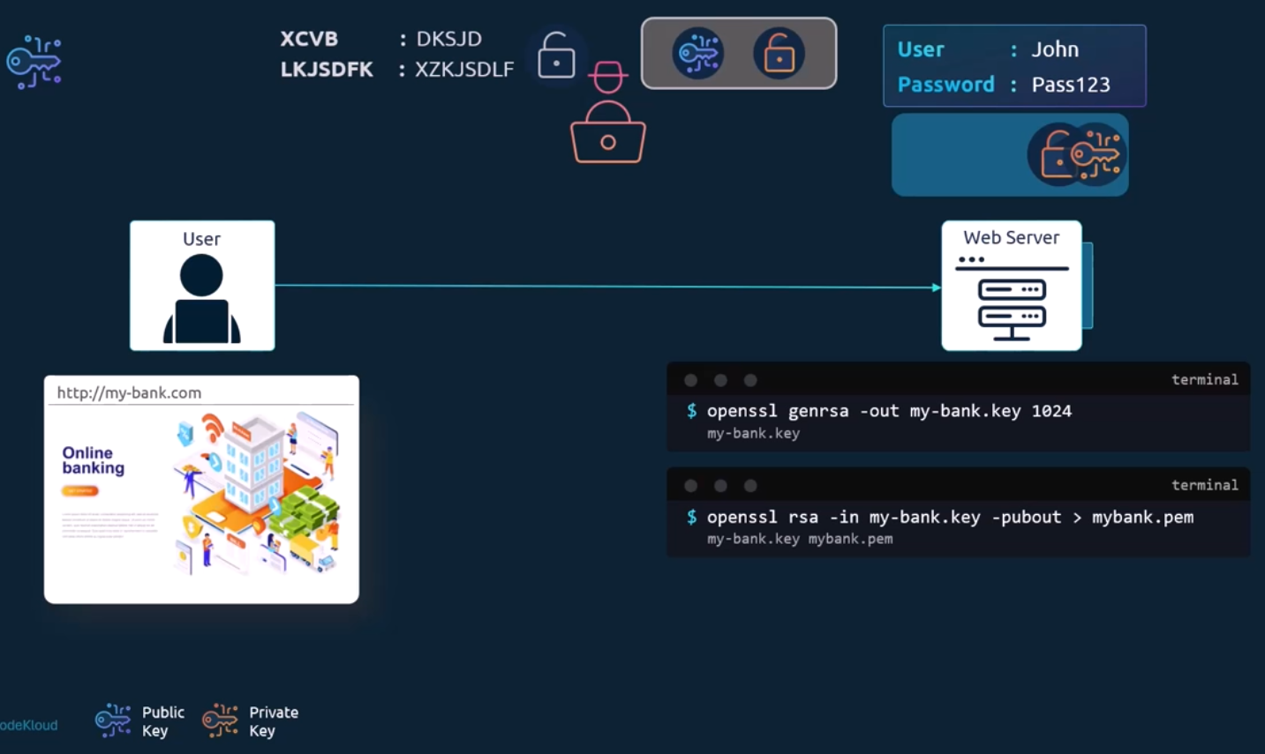
The hacker now looks for new ways to hack into your account and he realizes that the only way he can get your credentials is by getting you to type it into a form he presents. he creates a website that looks exactly like your bank's website. The design is the same, the graphics are the same, the website is a replica of the actual bank's website. He hosts the website on his own server, he wants you to think it's secure. Two so he generates his own set of public and private key pairs and configures them on his web server and finally, he somehow manages to tweak your environment or your network to route your requests, going to your bank's website, to his servers. When you open up your browser and type the website address in, you see a very familiar page. The same login page of your bank that you're used to seeing. you go ahead and type in the username and password. You make sure you type them https in the URL to make sure the communication is secure and encrypted. Your browser receives a key, you send encrypted symmetric key, and then you send your credentials encrypted with the key, and the receiver decrypts the credentials with the same symmetric key. You've been communicating securely in an encrypted manner, but with the hacker's server. As soon as you send any credentials, you see a dashboard that doesn't look very much like your bank's dashboard.
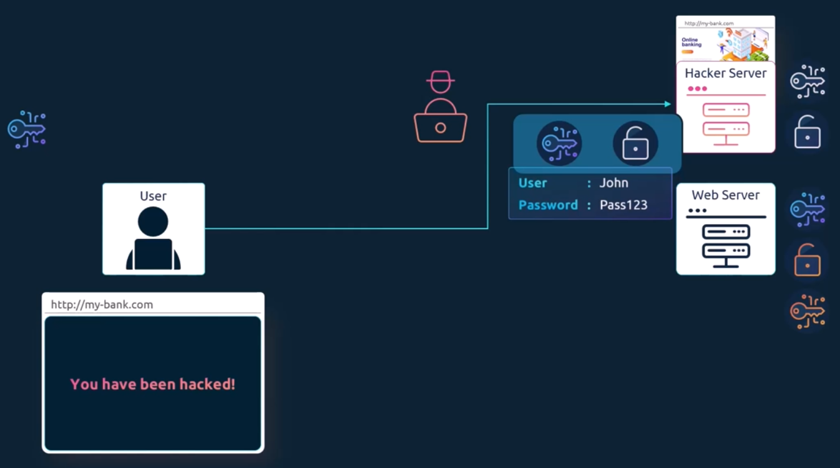
What if you could look at the key you received from the server and say, if it is a legitimate key from the real bank server, when the server sends the key, it does not send the key alone. It sends a certificate that has the key in it.
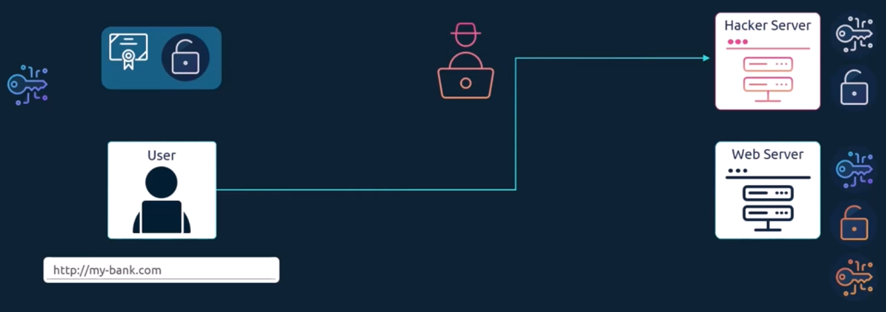
If you take a closer look at the certificate, you will see that it is like an actual certificate, but in a digital format. It has information about who the certificate is issued to, the public key of that server, the location of that server, etc. on the right you see the output of an actual certificate. Every certificate has a name on it, the person or subject to whom the certificate is issued to. That is very important as that is the field that helps you validate their identity is this is for a web server. This must match what the user types in in the URL on his browser. If the bank is known by any other names, and if they like their users to access their application with the other names as well, then all those names should be specified in this certificate under the subject Alternative Names section.
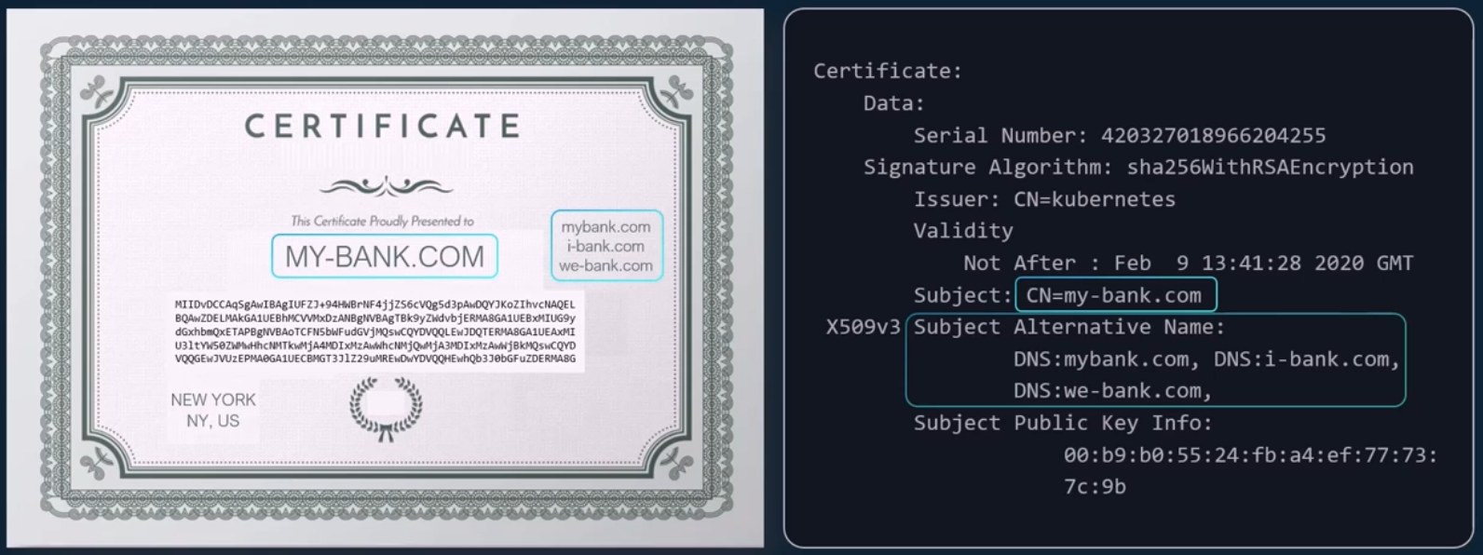
But you see, anyone can generate a certificate like this. You could generate one for yourself saying you're Google and that's what the hacker did. He generated a certificate saying he is your bank's website. So how do you look at a certificate and verify if it is legit? That is where the most important part of the certificate comes into play. Who signed and issued the certificate? If you generated a certificate then you will have to sign it by yourself. That is known as a self-signed certificate. Anyone looking at the certificate you generated will immediately know that it is not a safe certificate, because you have signed it.
If you looked at the certificate you received from the hacker closely, you would have noticed that it was a fake certificate that was signed by the hacker himself. As a matter of fact, your browser does that for you. All of the web browsers are built in with a certificate validation mechanism, wherein the browser checks the certificate received from the server and validates it to make sure it is legitimate. If it identifies it to be a fake certificate, then it actually warns you. So then how do you create a legitimate certificate for your web servers that the web browsers will trust? How do you get your certificates signed by someone with authority? That's where certificate authorities or CAS comes in. They're well-known organizations that can sign and validate your certificates for you. Some of the popular ones are Symantec, DigiCert, Comodo, GlobalSign, etc.

The way this works is you generate a certificate, signing request or CSR using the key you generated earlier and the domain name of your website. You can do this again using the OpenSSL command. This generates a MY-BANK.com CSR file, which is the certificate signing request that should be sent to the CA for signing, it looks like this.
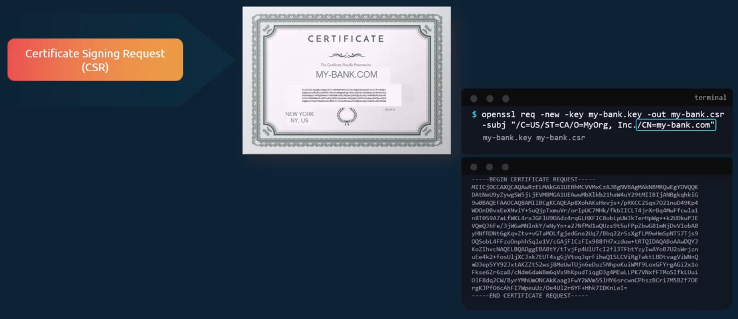
The certificate authorities verify your details and once it checks out, they sign the certificate and send it back to you. You now have a certificate signed by a CA that the browsers trust.
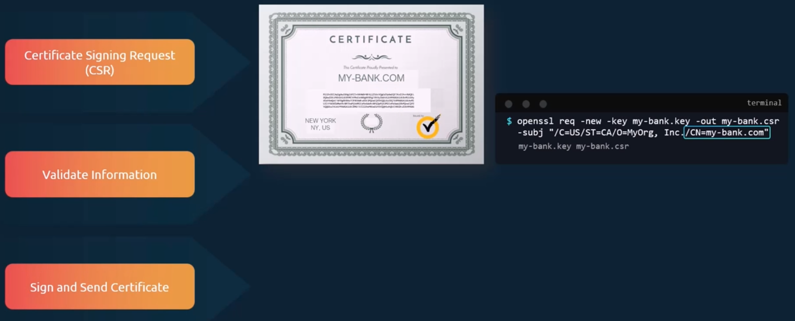
If hacker tried to get his certificate signed the same way, he would fail during the validation phase and his certificate would be rejected by the CA. the website that he is hosting won't have a valid certificate. The CS used different techniques to make sure that you are the actual owner of that domain. You now have a certificate signed by CA that the browsers trust. But how do browsers know that the CA itself was legitimate? For example, what if the certificate was signed by a fake CA? In this case, our certificate was signed by Symantec. How would the browser know Symantec is a valid CA and that the certificate was in fact signed by Symantec, and not by someone who says they are Symantec. The CA themselves have a set of public and private key pairs.
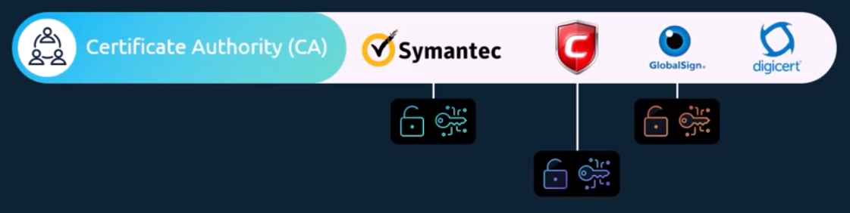
The CA's used their private keys to sign the certificates. The public keys of all the CAS are built in to the browsers. The browser uses the public key of the CA to validate that the certificate was actually signed by the CA themselves.
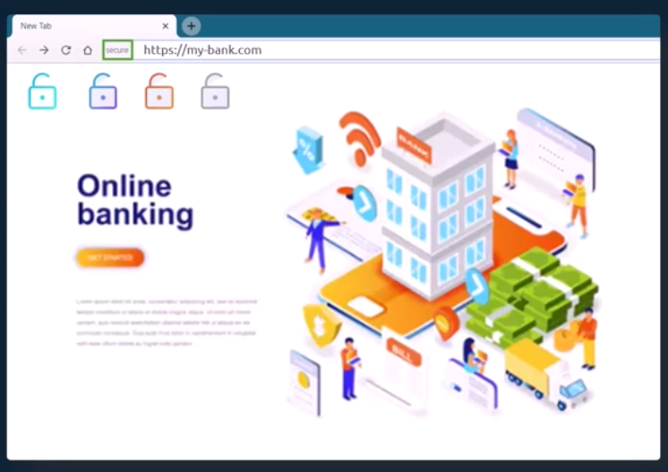
You can actually see them in the settings of your web browser under certificates. They are under trusted CAS tab.
Now these are public CAS that help us ensure the public websites we visit like our banks, emails, etc. are legitimate.
However, they don't help you validate sites hosted privately, say within your organization. For example, for accessing your payroll or internal email applications. For that, you can host your own private CAS. Most of these companies listed here have a private offering of their services a CAS server that you can deploy internally within your company. You can then have the public key of your internal CA server installed on all your employees’ browsers, and establish secure connectivity within your organization.
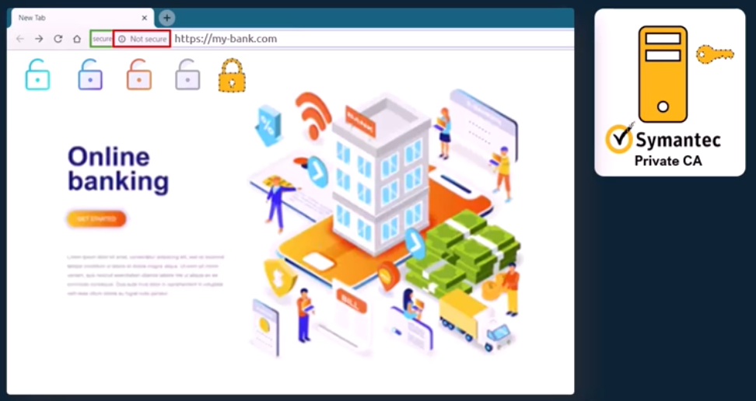
let's summarize really quick. We've seen why you may want to encrypt messages being sent over a network to encrypt messages. We use asymmetric encryption with a pair of public and private keys. An admin uses a pair of keys to secure SSH connectivity to the servers. The server uses a pair of keys to secure Https traffic. But for this, the server first sends a certificate signing request to a CA. The CA uses its private key to sign the CSR. Remember, all users have a copy of the CAS public key. The signed certificate is then sent back to the server. The server configures the web application with the signed certificate. Whenever a user accesses the web application, the server first sends the certificate with its public key. The user, or rather the user's browser, reads the certificate and uses the CA's public key to validate and retrieve the server's public key. It then generates a symmetric key that wishes to use going forward for all communication. The symmetric key is encrypted using the server's public key and sent back to the server. The server uses its private key to decrypt the message and retrieve the symmetric key. The symmetric key is used for communication going forward, so the administrator generates a key pair for securing SSH. The web server generates a key pair for securing the website with Https. The certificate authority generates its own set of key pair to sign certificates. The end user, though, only generates a symmetric key. Once he establishes trust with the website. He uses his username and password to authenticate to the web server. with the server's key pairs, the client was able to validate that the server is who they say they are, but the server does not for sure know if the client is who they say they are. It could be a hacker impersonating a user by somehow gaining access to his credentials. Note over the network for sure, as we have secured it already with TLS. Maybe by some other means. Anyway, so what can the server do to validate that the client is who they say they are? For this, as part of the initial trust building exercise, the server can request a certificate from the client, and so the client must generate a pair of keys and a signed certificate from a valid CA. The client then sends the certificate to the server for it to verify that the client is who they say they are. Now you must be thinking you have never generated a client certificate to access a website. Well, that's because TLS client certificates are not generally implemented on web servers. Even if they are, it's all implemented under the hood, a normal user doesn’t have to generate and manage certificates manually.
So that was the final piece about client certificates. This whole infrastructure, including the CA, the servers, the people, and the process of generating, distributing and maintaining digital certificates is known as public key infrastructure or PKI.
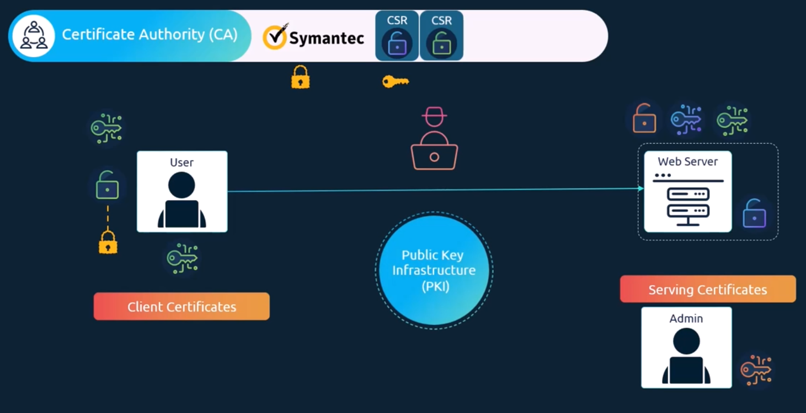
Finally, let me clear up something before you leave. I've been using the analogy of a key and lock for private and public keys. If I give you the impression that only the lock or the public key can encrypt data, then please forgive me as it's not true. These are in fact two related or paired keys. You can encrypt data with any one of them and only decrypt data with the other. You cannot encrypt data with one and decrypt with the same. you must be careful what you encrypt your data with. If you encrypt your data with your private key, then remember anyone with your public key, which could really be anyone out there, will be able to decrypt and read your message.
Finally, a quick note on naming convention. Usually, certificates with public key are named CRT or PEM extension. So that's server.crt or server.pem for server certificates or client.crt or client.pem for client certificates.
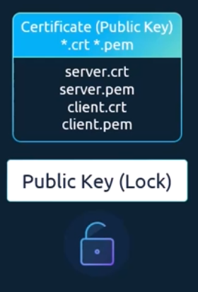
And private keys are usually with extension key or dash key. For example, server.key or server-key.pem. So just remember private keys have the word key in them, usually either as an extension or in the name of the certificate, and one that doesn't have the word key in them is usually a public key or certificate.
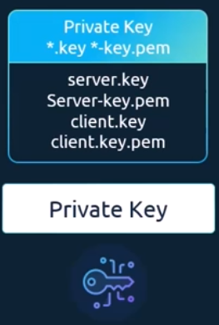

TLS in Kubernetes:
we look at securing your Kubernetes cluster with TLS certificates. we saw what public and private keys are, how a server uses public and private keys to secure connectivity. We will call them serving certificates. we saw what a certificate authority is. we learned that the CA has its own set of public and private key pairs that it uses to sign server certificates. we will call them root certificates. we also saw how a server can request a client to verify themselves using client certificates. three types of certificates, Server certificates configured on the server's root certificate configured on the CA servers, and then client certificates configured on the clients.
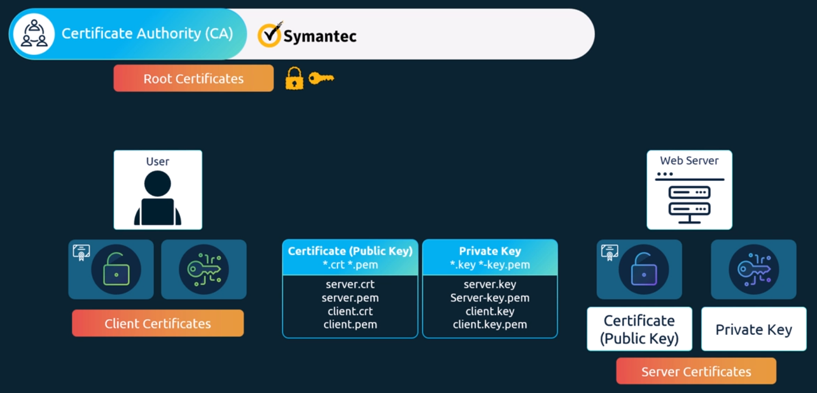
And a quick note on naming convention. Before we go forward, you're going to see a lot of certificate files in this lecture and it could be very confusing. use this technique to know which one is which. Usually, certificates with public keys are named CRT or PEM extension. that's server CRT or server PEM for server certificates or client CRT or client PEM for client certificates and private keys are usually with extension key or with a key in the file names, for example server.key or server-key.pem. just remember private keys have the word key in them usually, either as an extension or in the name of the certificate, and one that doesn't have the word key in them is usually a public key or certificate.
We will now see how these concepts relate to a Kubernetes cluster. The Kubernetes cluster consists of a set of master and worker nodes. Of course, all communication between these nodes needs to be secure and must be encrypted. All interactions between all services and their clients need to be secure. For example, an administrator interacting with a Kubernetes cluster through the kube control utility or via accessing the Kubernetes API directly must establish secure TLS connection, communication between all the components within the Kubernetes cluster also need to be secured. the two primary requirements are to have all the various services within the cluster to use server certificates, and all clients to use client certificates to verify they are who they say they are.
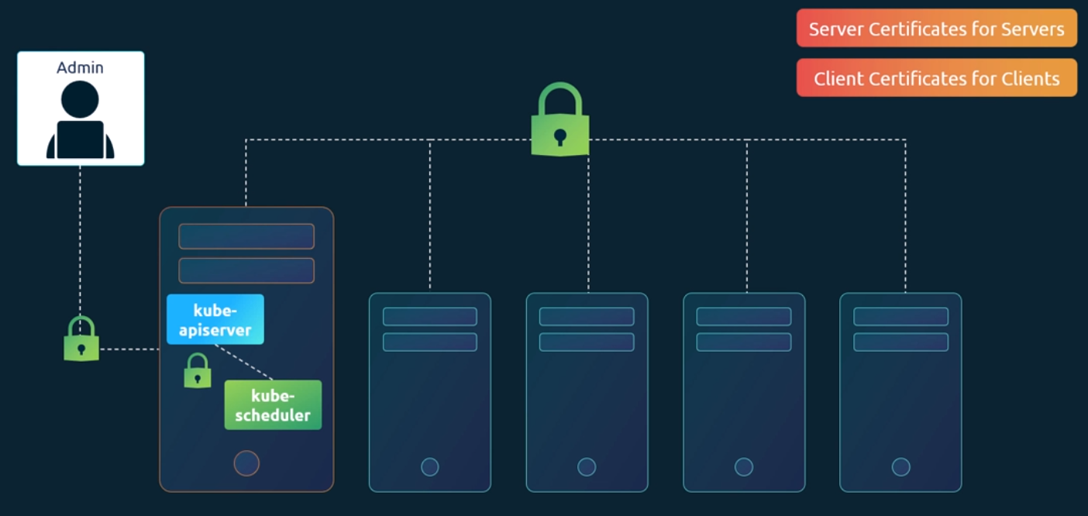
Let's look at the different components within the Kubernetes cluster and identify the various servers and clients and who talks to who. Let's start with the kube API server. As we know already, the API server exposes an Https service that other components as well as external users use to manage the Kubernetes cluster. it is a server and it requires certificates to secure all communication with its clients. we generate a certificate and key pair. We call it apiserver.cert and apiserver.key. We will try to stick to this naming convention going forward. Anything with a crt extension is the certificate and key extension is the private key.
Also remember, the certificate names could be different in different Kubernetes setups depending on who and how the cluster was set up. these names may be different in yours. we will try to use names that help us easily identify the certificate files.
Another server in the cluster is the etcd server. The etcd server stores all information about the cluster, so it requires a pair of certificate and key for itself. we will call it etcdserver.crt and etcdserver.key.
The other server component in the cluster is on the worker nodes. There are the Kubelet services. They also expose an https api endpoint that the kube API server talks to interact with the worker nodes. Again, that requires a certificate and key pair. We call it kubelet.cert and kubelet.key.
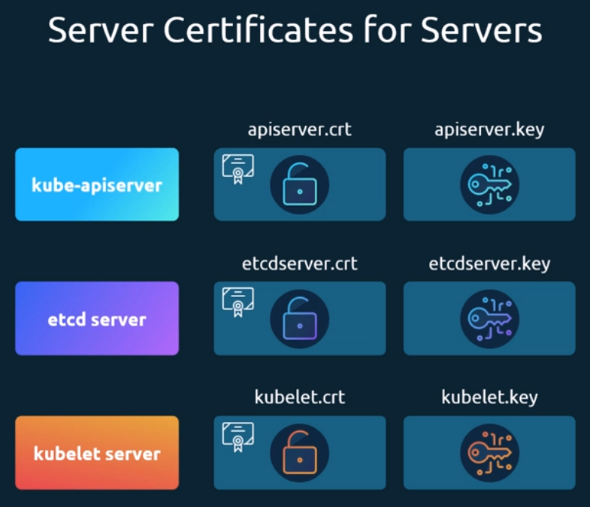
Those are really the server components in the Kubernetes cluster.
Let's now look at the client components. Who are the clients who access these services?
The clients who access the kube API server are us the administrators through kube control or Rest API. The admin user requires a certificate and key pair to authenticate to the kube API server. We will call it admin.crt and admin.key.
The scheduler talks to the kube API server to look for pods that require scheduling, and then get the API server to schedule the pods on the right worker nodes. The scheduler is a client that accesses the kube API server. As far as the kube API server is concerned, the scheduler is just another client like the admin user, the scheduler needs to validate its identity using a client TLS certificate. it needs its own pair of certificate and keys. We will call it scheduler.crt and scheduler.key.
The kube controller manager is another client that accesses the kube API server, so it also requires a certificate for authentication to the kube API server. we create a certificate pair for it.
The last client component is the kube proxy. The kube proxy requires a client certificate to authenticate to the kube API server, and so it requires its own pair of certificate and keys. We will call them kube-proxy.crt and kube-proxy.key.
The servers communicate amongst them as well. For example, the kube API server communicates with the etcd server. In fact, of all the components, the kube API server is the only server that talks to the etcd server. So as far as the etcd server is concerned, the kube API server is a client, so it needs to authenticate. The kube API server can use the same keys that it used earlier for serving its own API service, the apiserver.crt and the apiserver.key files. Or you can generate a new pair of certificates specifically for the kube API server to authenticate to the etcd server.
The kube API server also talks to the Kubelet server on each of the individual nodes. That's how it monitors the worker nodes. For this, again, it can use the original certificates or generate new ones specifically for this purpose.
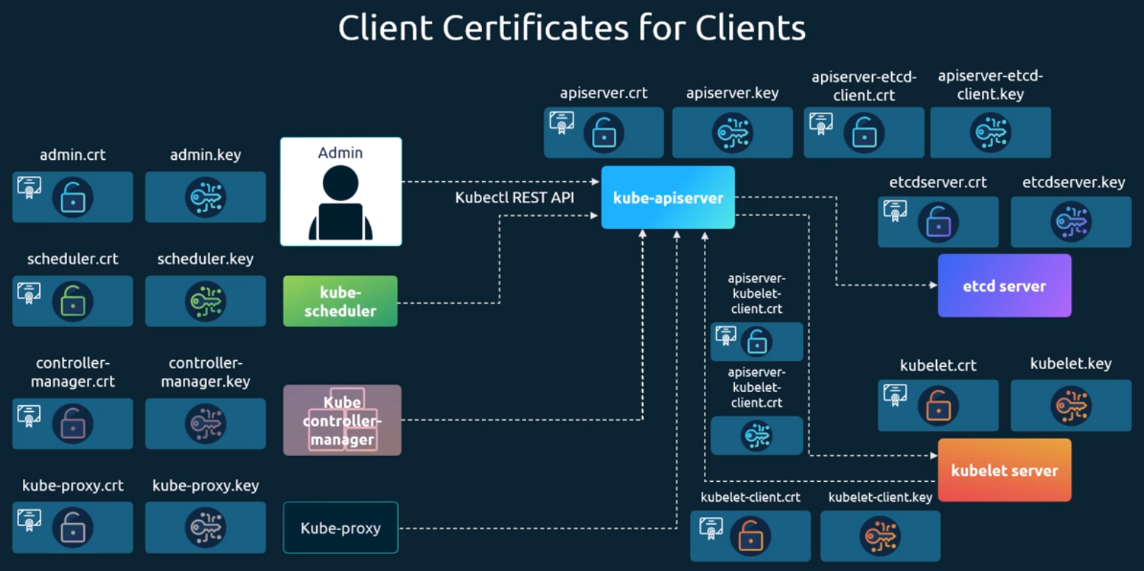
So that's too many certificates. Let's try and group them. There are a set of client certificates, mostly used by clients to connect to the API server, and there are a set of server-side certificates used by the API server, etcd server and Kubelet to authenticate their clients. We will now see how to generate these certificates. As we know already, we need a certificate authority to sign all of these certificates.
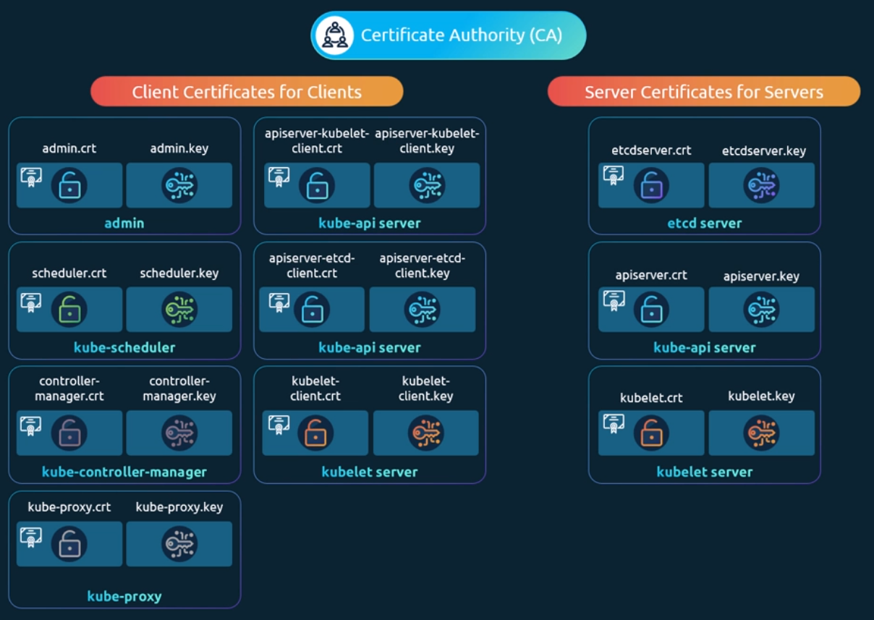
Kubernetes requires you to have at least one certificate authority for your cluster. In fact, you can have more than one for all the components in the cluster, and another one specifically for etcd. In that case, the etcd server certificates and etcd servers client certificates, which in this case is the API server client certificate will be all signed by etcd server CA.
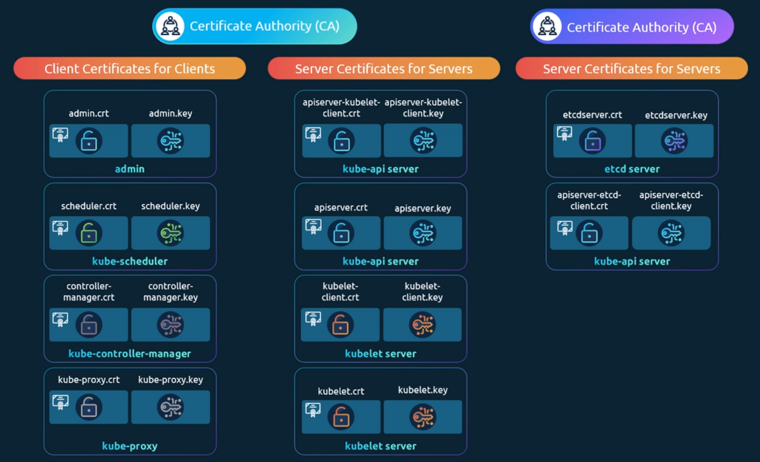
For now, we will stick to just one CA for our cluster. The CA as we know has its own pair of certificate and key. We will call it ca.crt and ca.key that should sum up all the certificates used in the cluster.
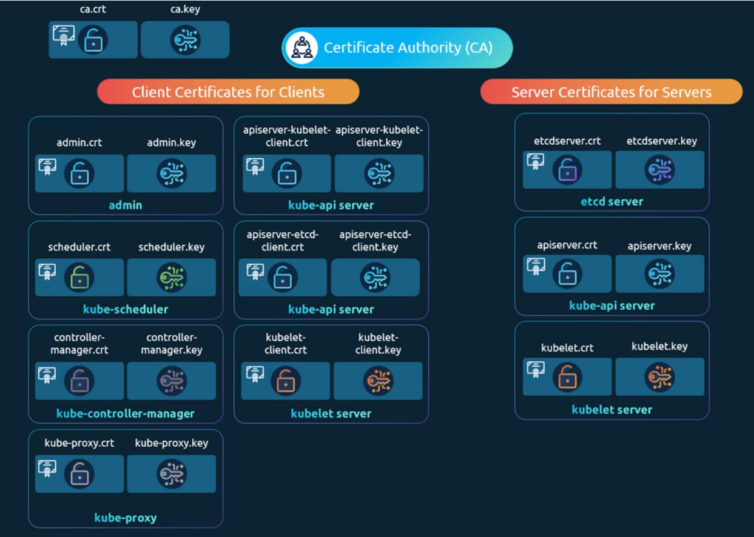

TLS in Kubernetes - Certificate Creation:
We'll look at how to generate the certificates for the cluster to generate certificates. There are different tools available such as easy RSA, OpenSSL or SSL etc. or many others. we will use OpenSSL tool to generate certificates.
We will start with the CA certificates. First, we create a private key using the OpenSSL command OpenSSL GENRSA dash out CA key. Then we use the OpenSSL request command along with the key we just created to generate a certificate signing request. The certificate signing request is like a certificate with all of your details, but with no signature. In the certificate signing request, we specify the name of the component the certificate is for in the common name or CN field. In this case, since we are creating a certificate for the Kubernetes CA, we name it Kubernetes dash CA. Finally, we sign the certificate using the OpenSSL x509 command and by specifying the certificate signing request we generated in the previous command. Since this is for the CA itself, it is self-signed by the CA using its own private key that it generated in the first step.
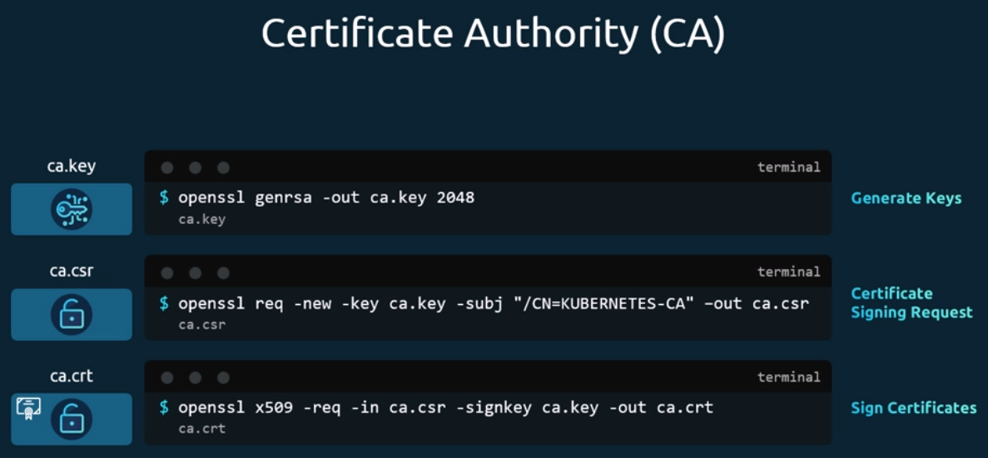
Going forward for all other certificates, we will use the CA key pair to sign them. The CA now has its private key and root certificate file.
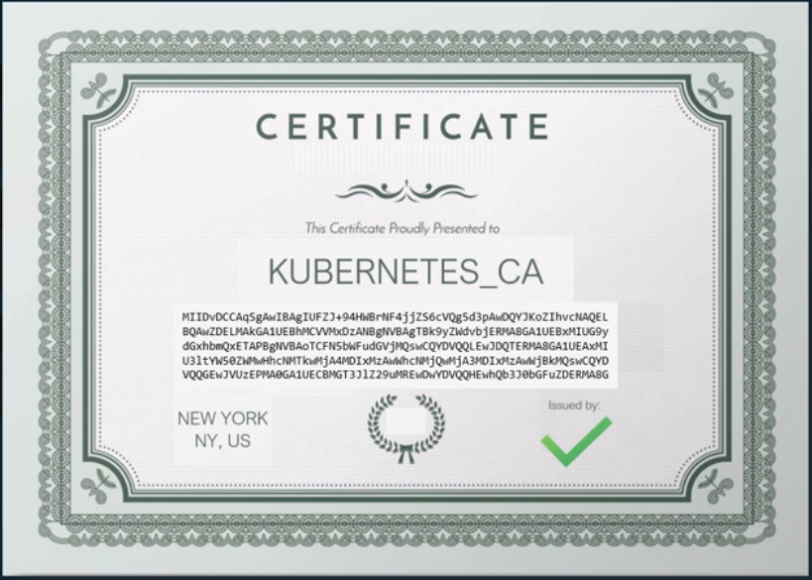
Let's now look at generating the client certificates. We start with the admin user. We follow the same process where we create a private key for the admin user using the OpenSSL command. We then generate a CSR and that is where we specify the name of the admin user which is kube admin. A quick note about the name, it doesn't really have to be kube admin. It could be anything but remember this is the name that kube control client authenticates with and when you run the kube control command. So, in the audit logs and elsewhere This is the name that you will see, so provide a relevant name in this field. Finally, generate a signed certificate using the OpenSSL x five zero nine command.
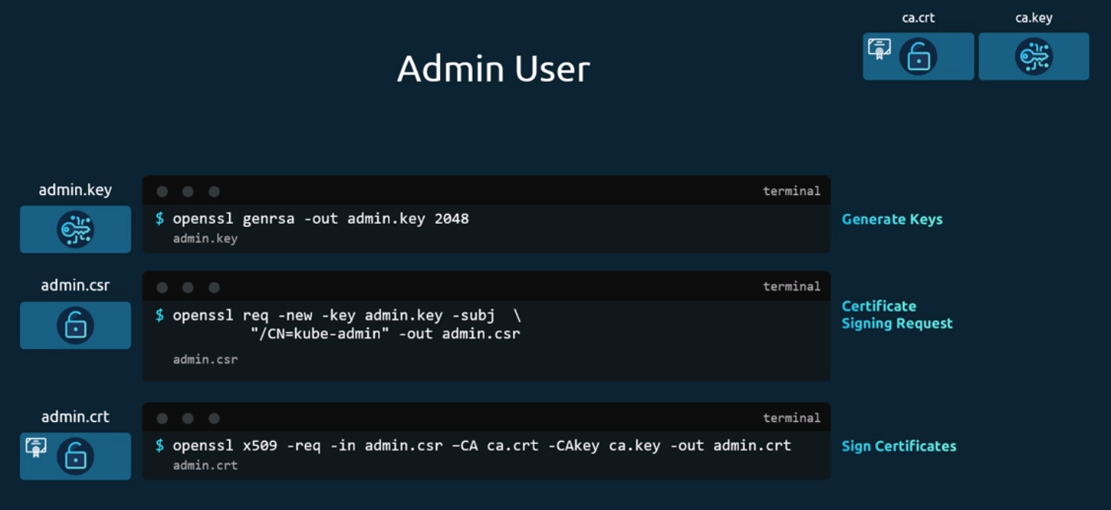
But this time you specify the CA certificate and the CA key. You're signing your certificate with the CA key pair. That makes this a valid certificate within your cluster. The signed certificate is then output to admin.crt file. That is the certificate that the admin user will use to authenticate to Kubernetes cluster. If you look at it, this whole process of generating a key and a certificate pair is similar to creating a user account for a new user, the certificate is the validated user ID and the key is like the password. It's just that it's much more secure than a simple username and password.
This is for the admin user. How do you differentiate this user from any other users? The user account needs to be identified as an admin user and not just another basic user. You do that by adding the group details for the user in the certificate. In this case, a group named System Masters exist on Kubernetes with administrative privileges. We will discuss about groups later, but for now it's important to know that you must mention this information in your certificate signing request. You can do this by adding group details with the OU parameter while generating a certificate signing request. Once it's signed, we now have our certificate for the admin user with admin privileges.
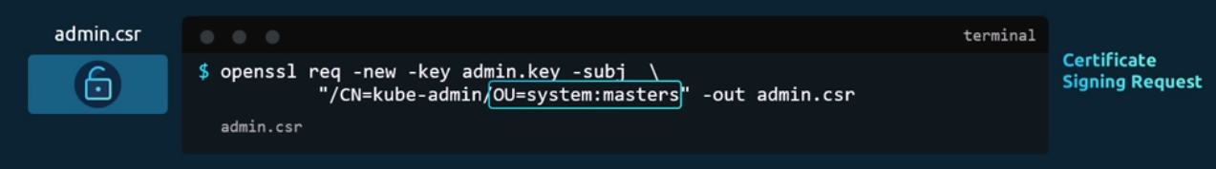
We follow the same process to generate client certificates for all other components that access the kube API server.
The kube scheduler. Now the kube scheduler is a system component part of the Kubernetes control plane, so its name must be prefixed with the keyword system.
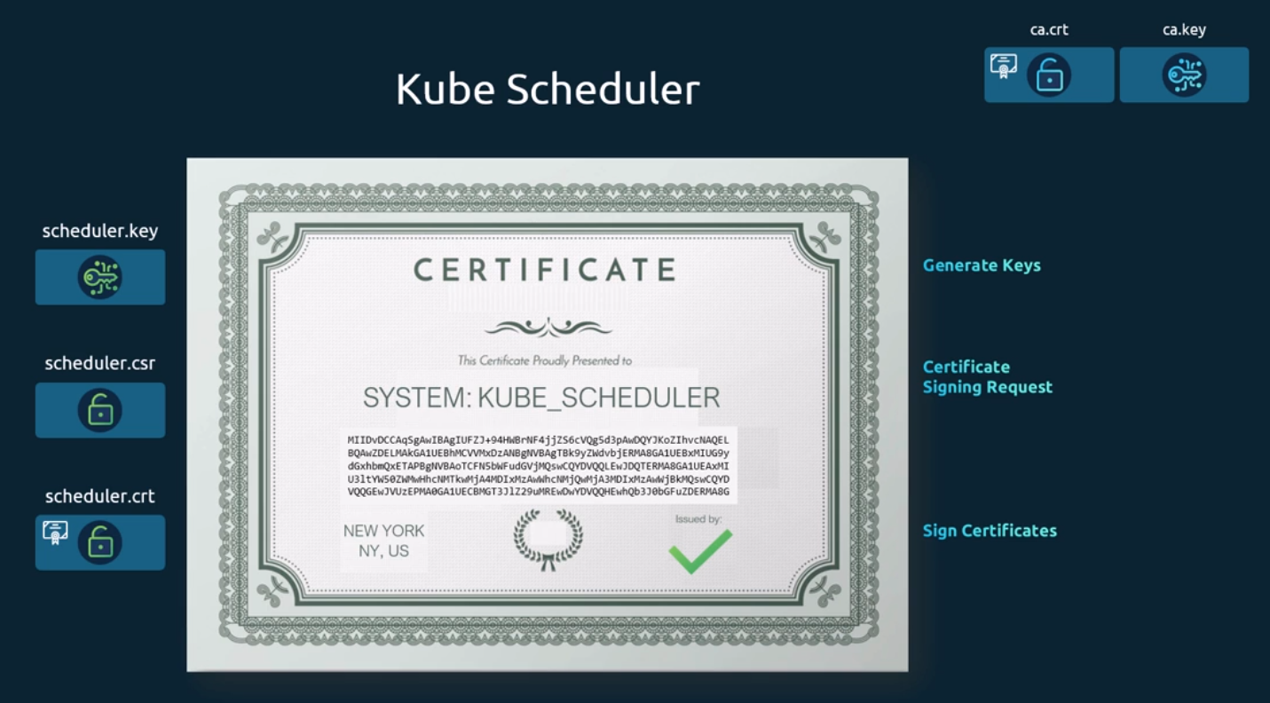
The same with kube controller manager. It is again a system component, so its name must be prefixed with the keyword system.
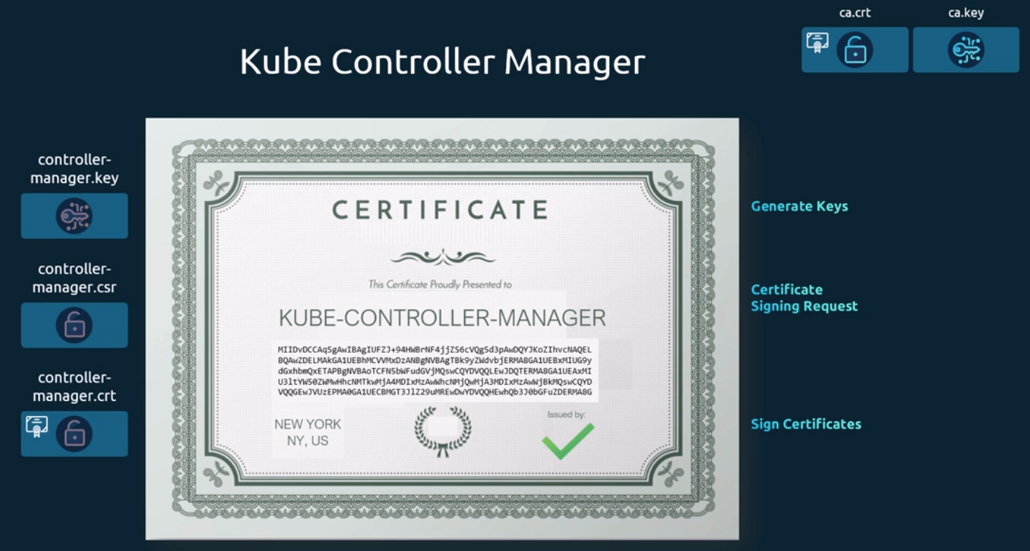
Finally, kube proxy.
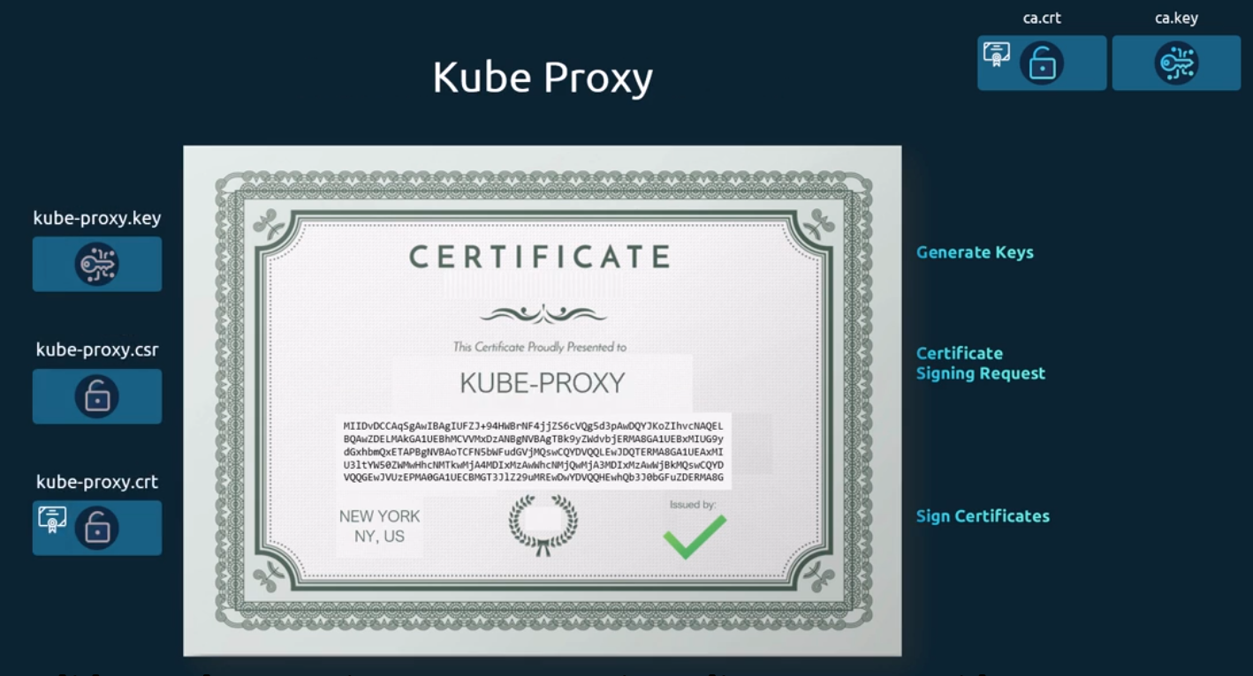
So far, we have created CA certificates. Then all of the client certificates including the admin, user scheduler, controller manager and kube proxy. We will follow the same procedure to create the remaining three client certificates for API servers and kubelets. When we create the server certificates for them, so we will set them aside for now.
Now what do you do with these certificates? Take the admin certificate for instance to manage the cluster. You can use this certificate instead of a username and password. In a Rest API call you make to the kube API server. You specify the key, the certificate, and the CA certificate as options.
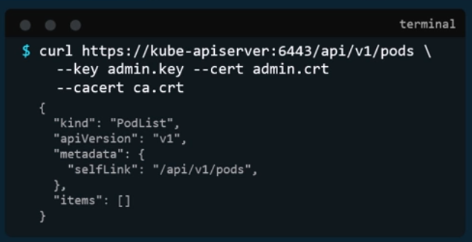
That's one simple way. The other way is to move all of these parameters into a configuration file called kube config. Within that, specify the API server endpoint, details, the certificates to use, etc. that is what most of the Kubernetes clients use.
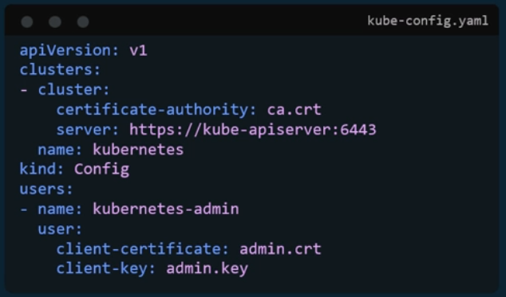
We will look at kube config in depth in one of the upcoming lectures. Okay, so we're now left with the server-side certificates. But before we proceed, one more thing. Remember, in the prerequisite lecture, we mentioned that for clients to validate the certificates sent by the server and vice versa, they all need a copy of the certificate authoritie’s public certificate, the one that we said is already installed within the user's browsers. In case of a web application. Similarly, in Kubernetes, for these various components to verify each other, they all need a copy of the CA's root certificate. whenever you configure a server or a client with certificates, you will need to specify the CA root certificate as well.
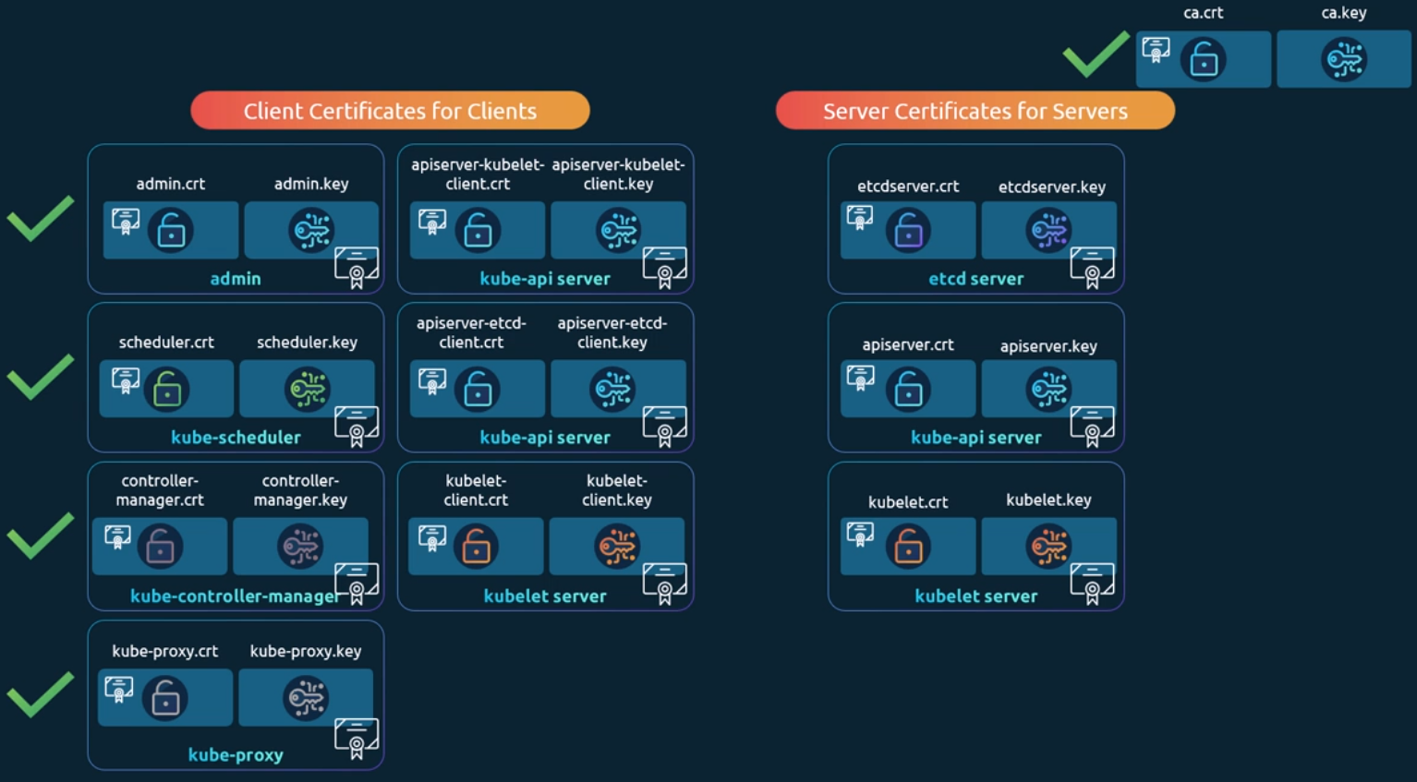
Let's look at the server side certificates now. Let's start with the etcd server. We follow the same procedure as before to generate a certificate for etcd. We will name it etcd server. Etcd server can be deployed as a cluster across multiple servers as in a high availability environment. In that case, to secure communication between the different members in the cluster, we must generate additional peer certificates.
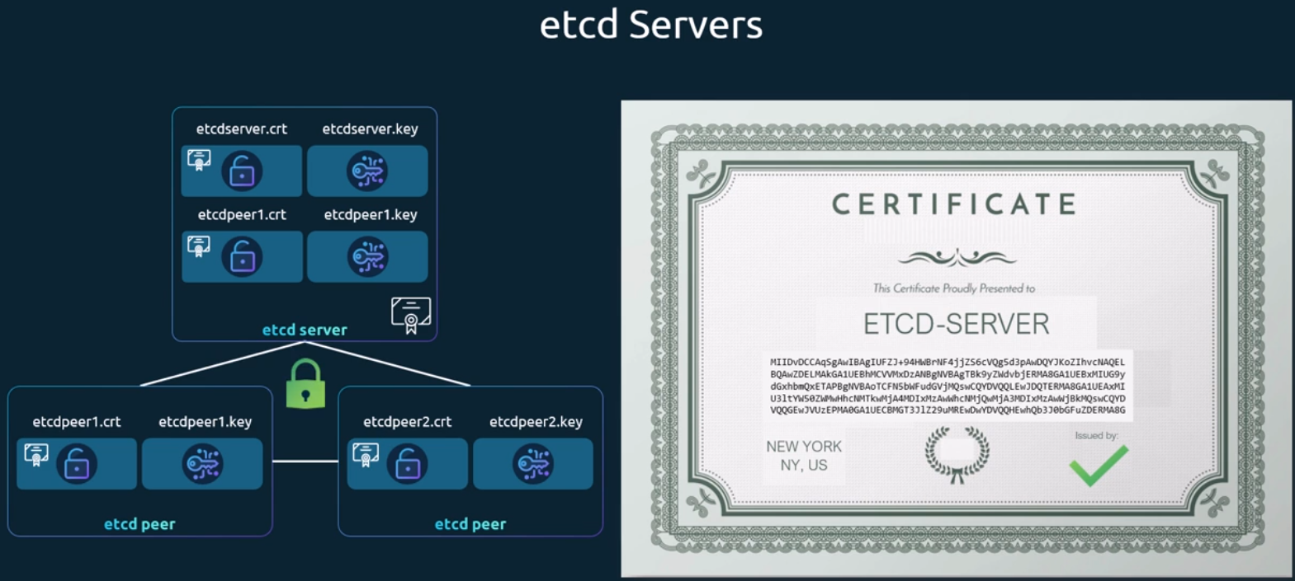
Once the certificates are generated, specify them while starting the etcd server. There are key and cert file options where you specify the etcd server keys. There are other options available for specifying the peer certificates. And finally, as we discussed earlier, it requires the CA root certificate to verify that the clients connecting to the etcd server are valid.
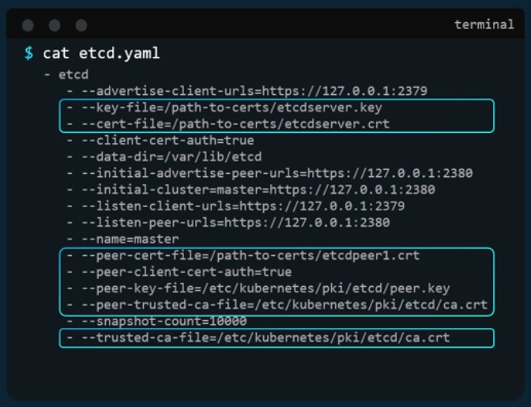
Let's talk about the kube API server now. We generate a certificate for the API server like before. But wait, the API server is the most popular of all components within the cluster. Everyone talks to the kube API server. Every operation goes through the kube API server. Anything moves within the cluster; the API server knows about it. You need information, you talk to the API server and it goes by many names and aliases within the cluster. Its real name is Kube API server, but some call it Kubernetes because for a lot of people who don't really know what goes under the hoods of Kubernetes? The kube API server is kubernetes, others like to call it kubernetes. Default, while some refer to it as kubernetes.default.svc and some like to call it by its full name kubernetes.default.svc.cluster.local. Finally, it is also referred to in some places simply by its IP address, the IP address of the host running the kube API server, or the pod running it, all of these names must be present in the certificate generated for the kube API server.
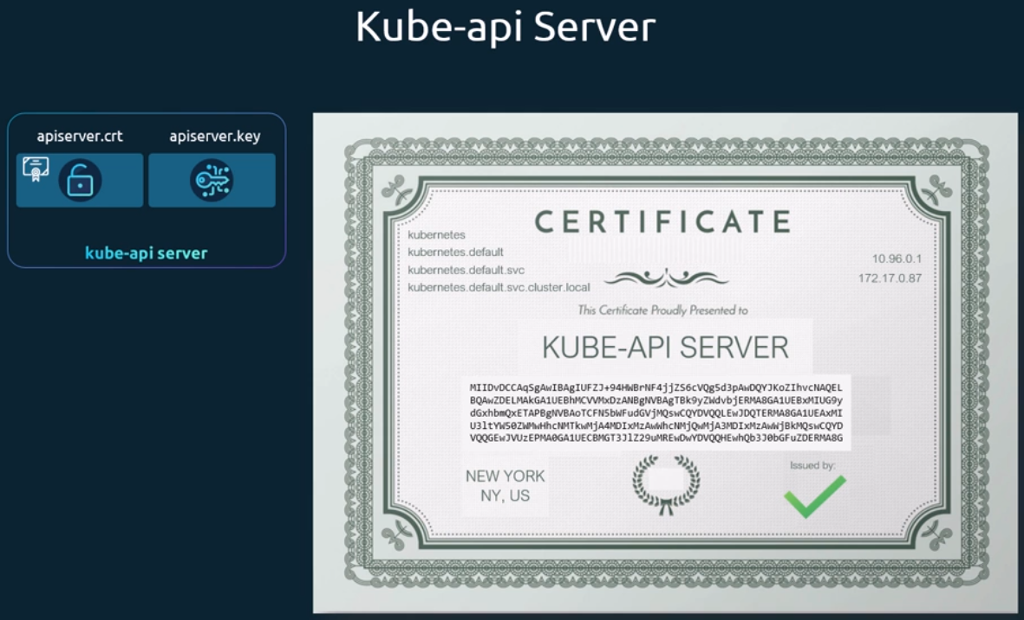
Only then those referring to the kube API server by these names will be able to establish a valid connection. we use the same set of commands as earlier to generate a key. In the certificate signing request you specify the name kube API server.
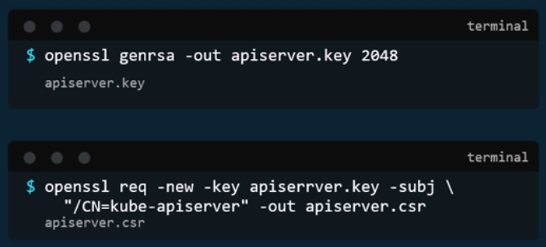
But how do you specify all the alternate names? For that you must create an open SSL config file. Create an OpenSSL conf file and specify the alternate names in the. Altnames section of the file. Include all the DNS names the API server goes by as well as the IP address. Pass this config file as an option while generating the certificate signing request. Finally, sign the certificate using the CA certificate and key. You then have the API server certificate. It is time to look at where we are going to specify these keys.
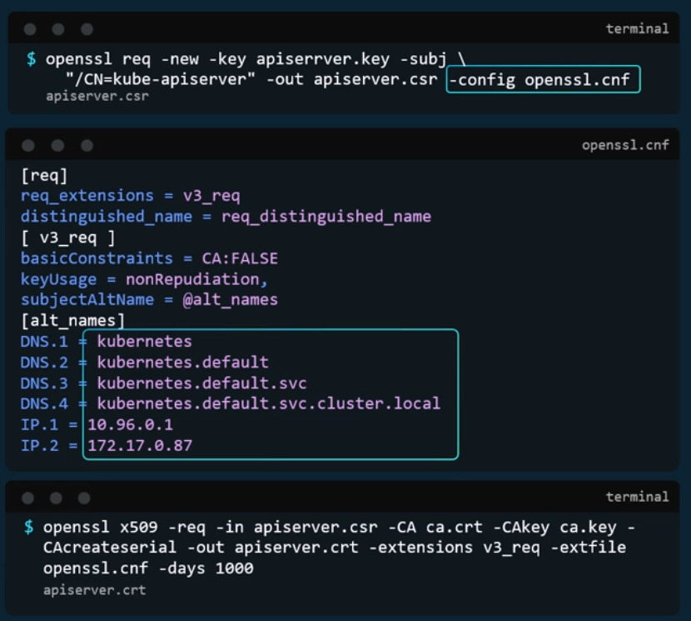
Remember to consider the API client certificates that are used by the API server while communicating as a client to the etcd and Kubelet servers. The location of these certificates is passed in to the kube API server's executable or service configuration file. First, the CA file needs to be passed in. Remember, every component needs the CA certificate to verify its clients. Then we provide the API server certificates under the TLS cert options. We then specify the client certificates used by kube API server to connect to the etcd server again with the CA file, and finally the kube API server client certificates to connect to the Kubelets.
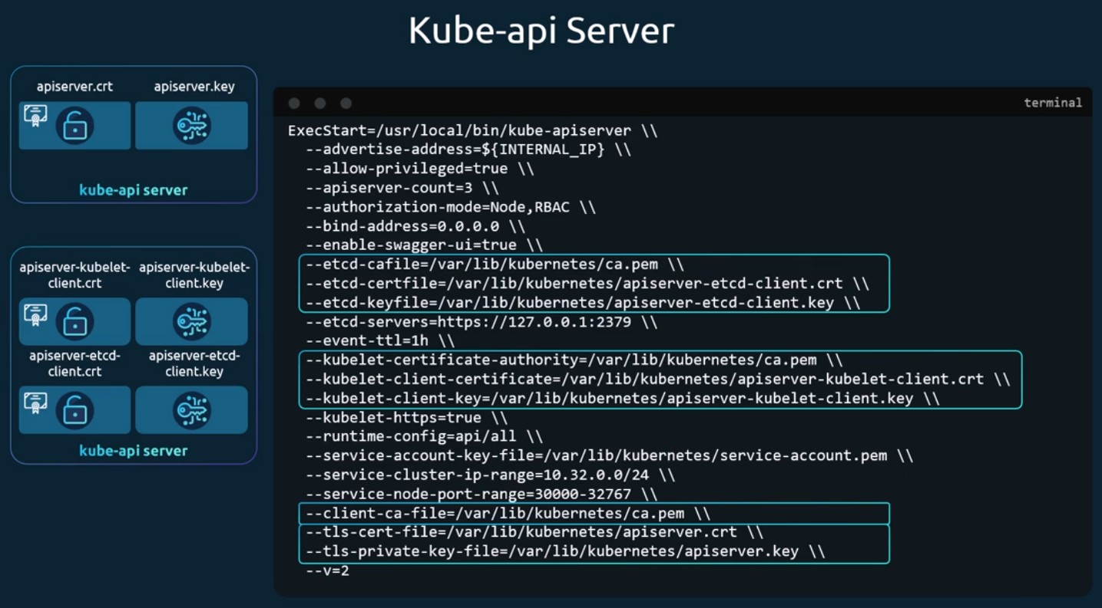
Next comes the Kubelet server. The Kubelet server is an https API server that runs on each node responsible for managing the node. That's who the API server talks to monitor the node, as well as send information regarding what pods to schedule on this node. As such, you need a key certificate pair for each node in the cluster. Now what do you name these certificates? Are they all going to be named Cubelets? No, they will be named after their nodes. Node zero one, node zero two and node zero three. Once the certificates are created, use them in the kubelet config file. As always, you specify the root certificate and then provide the Kubelet node certificates. You must do this for each node in the cluster.
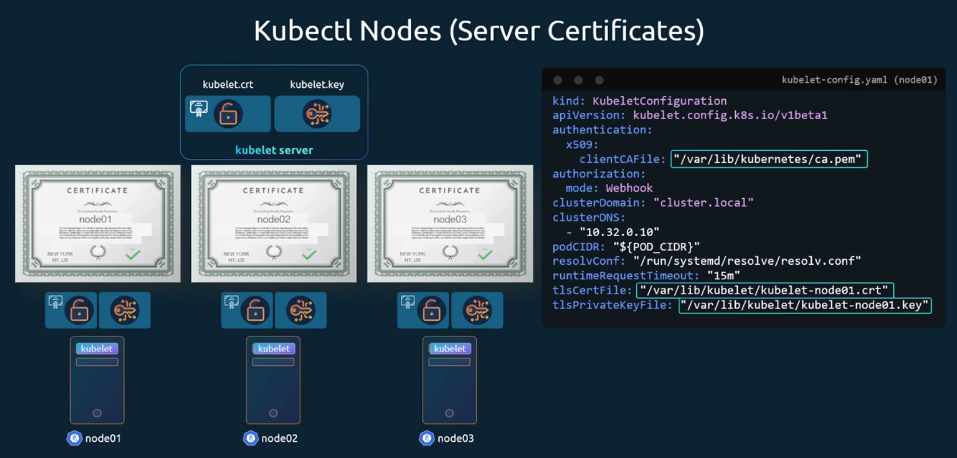
We also talked about a set of client certificates that will be used by the Kubelet to communicate with the kube API server. These are used by the Kubelet to authenticate into the kube API server. They need to be generated as well. What do you name these certificates? the API server needs to know which node is authenticating and give it the right set of permissions. it requires the nodes to have the right names in the right format. Since the nodes are system components like the kube scheduler and the controller manager we talked about earlier, the format starts with the system keyword followed by node and then the node name. In this case node one to node zero three. And how would the API server give it the right set of permissions? remember we specified a group name for the admin user. the admin user gets administrative privileges. Similarly, the nodes must be added to a group named system nodes. Once the certificates are generated, they go into the kube config files as we discussed earlier.
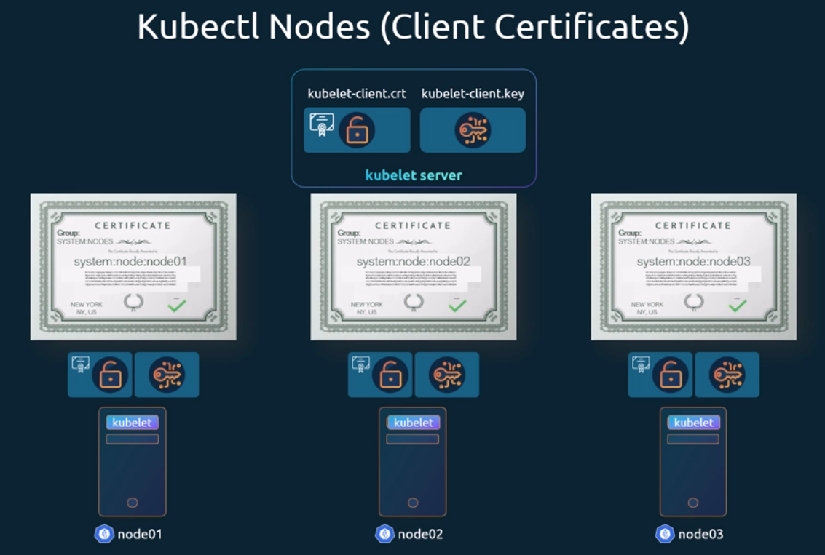

View Certificate Details:
We see how we can view certificates in an existing cluster. you join a new team to help them manage their Kubernetes environment. You're a new administrator to this team. You've been told that there are multiple issues related to certificates in the environment. you're asked to perform a health check of all the certificates in the entire cluster. What do you do? First of all, it's important to know how the cluster was set up. There are different solutions available for deploying a Kubernetes cluster, and they use different methods to generate and manage certificates. If you were to deploy a Kubernetes cluster from scratch, you generate all the certificates by yourself as we did in the previous lecture. Or else, if you were to rely on an automated provisioning tool like kube ADM, it takes care of automatically generating and configuring the cluster for you, while you deploy all the components as native services on the nodes in the hard way. The kube adm tool deploys these as pods. it's important to know where to look at to view the right information.
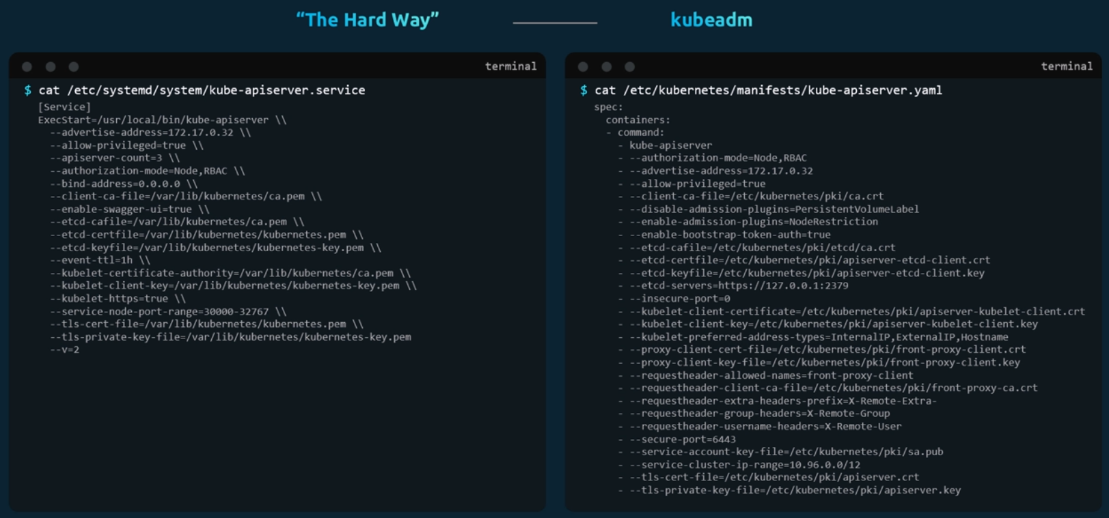
We're going to look at a cluster provisioned by kube ADM as an example. In order to perform a health check, start by identifying all the certificates used in the system. I've created a sample Excel spreadsheet for you. Check out the resources linked at the end of this lecture to access it. the idea is to create a list of certificate files used, their paths, the names configured on them, the alternate names configured, if any, the organization the certificate account belongs to the issuer of the certificate and the expiration date on the certificate. So how do you get these? Start with certificate files used for this in an environment set up by Kube ADM. Look for the kube API server definition file under slash Kubernetes slash manifests folder. The command used to start the API server has information about all the certificates it uses. Identify the certificate file used for each purpose and note it down.
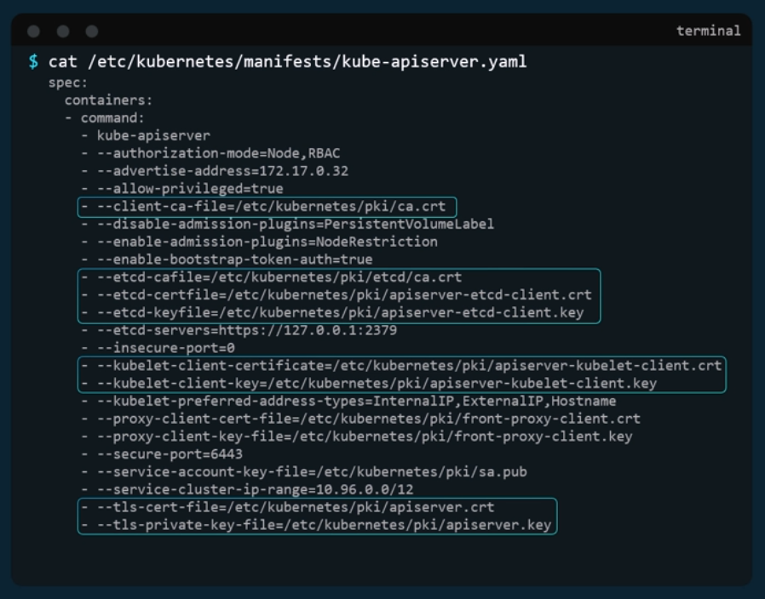
Next, take each certificate and look inside it to find more details about that certificate, for example. We will start with the API server certificate file. Run the OpenSSL x509 command and provide the certificate file as input to decode the certificate and view details. Start with the name on the certificate under the subject section. In this case it's kube API server. Then the alternate names. The kube API server has many, so you must ensure all of them are there, and then check the validity section of the certificate to identify the expiry date and then the issuer of the certificate. This should be the CA who issued the certificate. Kube ADM names the Kubernetes CA as Kubernetes itself.
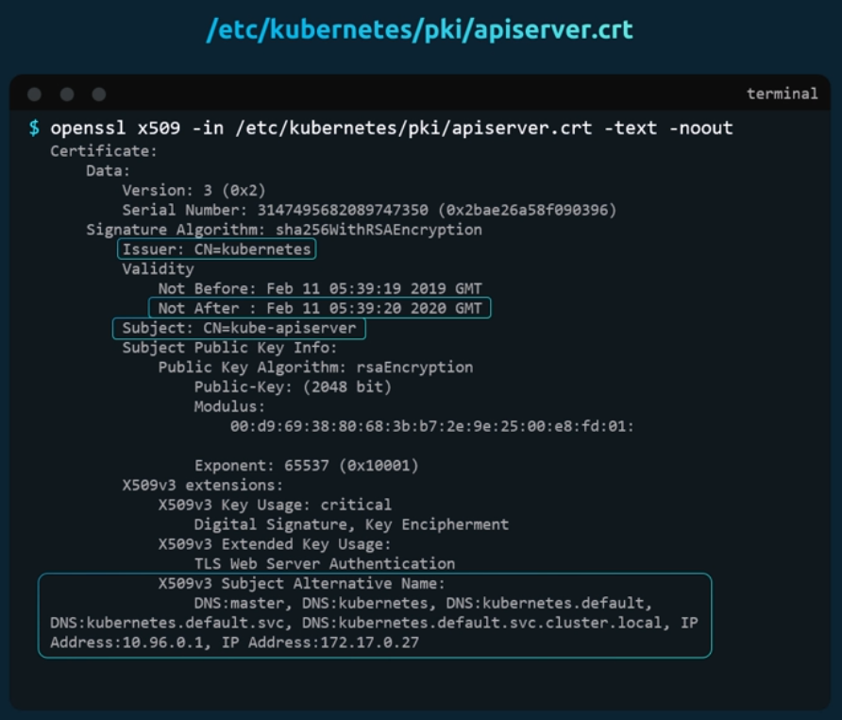
Follow the same procedure to identify information about all the other certificates. Things to look for. Check to make sure you have the right names, the right alternate names. Make sure the certificates are part of the correct organization, and most importantly, they are issued by the right issuer and that the certificates are not expired.
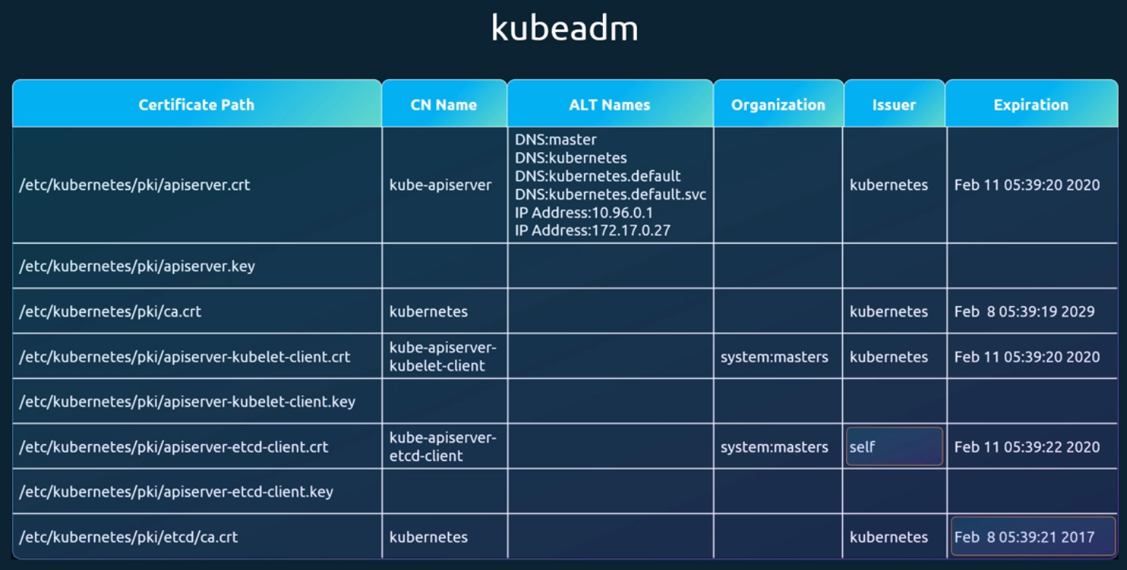
The certificate requirements are listed in detail in the Kubernetes documentation page.
Check the references section for the link. When you run into issues, you want to start looking at logs. If you set up the cluster from scratch by yourself and the services are configured as native services in the OS, you want to start looking at the service logs using the operating system's logging functionality.
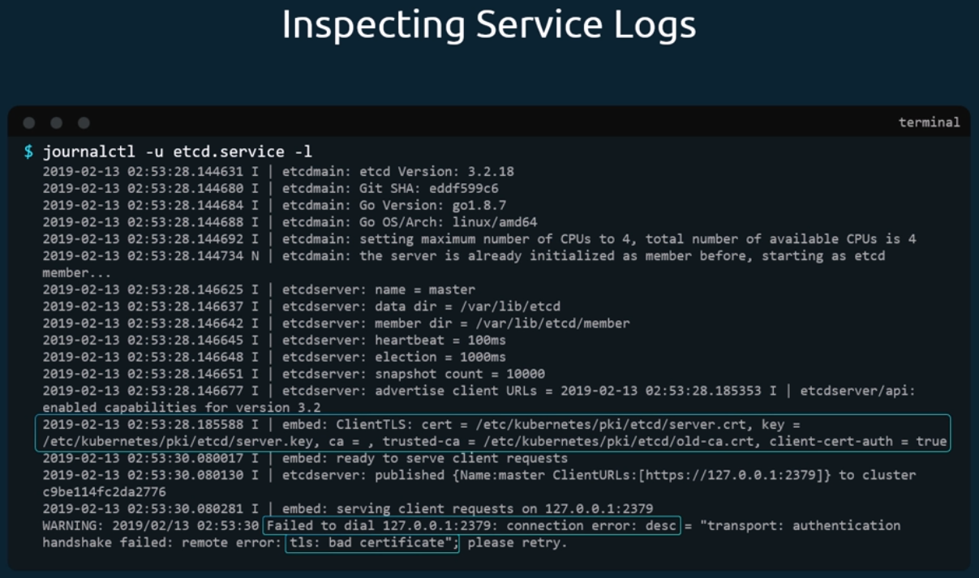
In case you set up a cluster with kube ADM, then the various components are deployed as pods. you can look at the logs using the kube control logs command followed by the pod name.
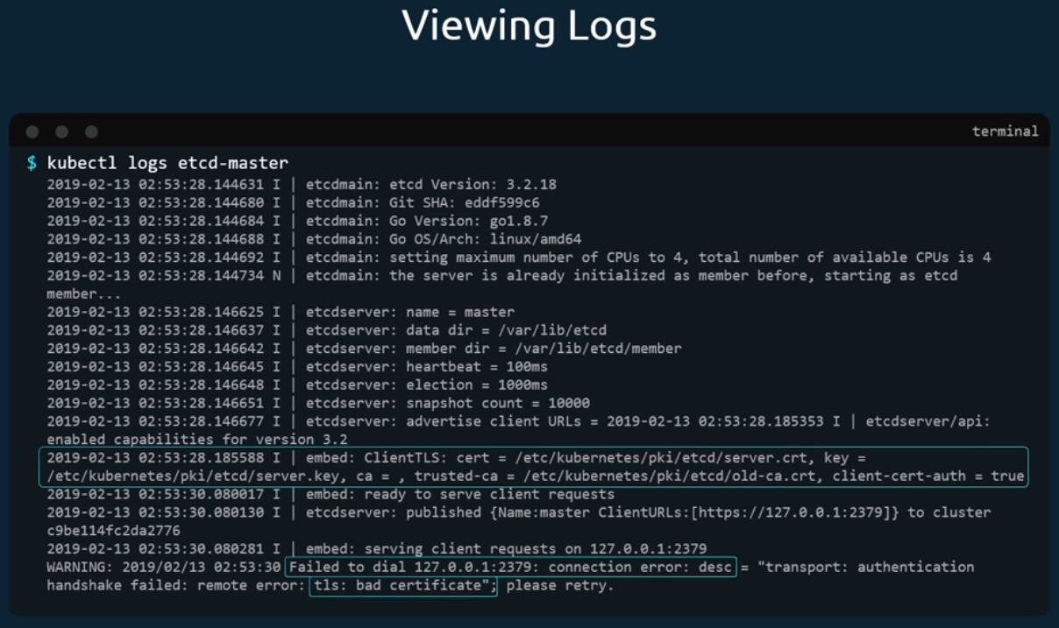
Sometimes if the core components, such as the Kubernetes API server or the etcd server are down, the kube control commands won't function. In that case, you have to go one level down to Docker to fetch the logs.
List all the containers using the crictl PS a command,
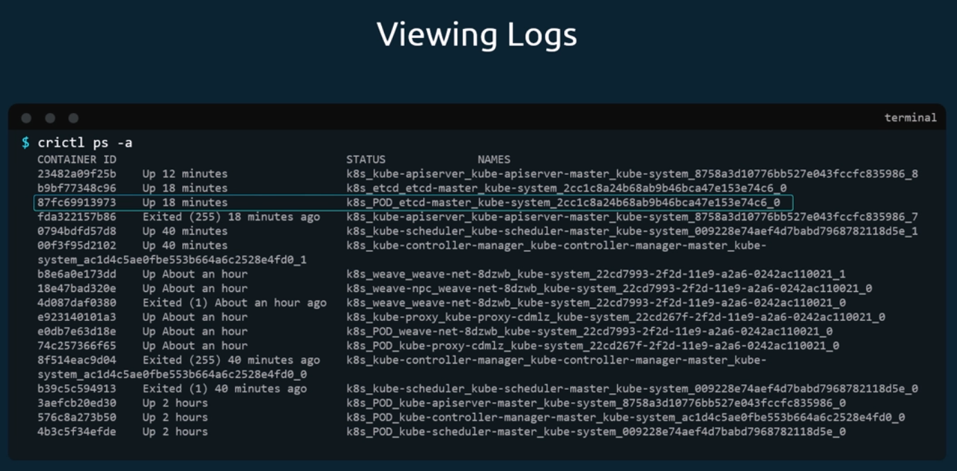
and then view the logs using crictl or logs command followed by the container ID.


